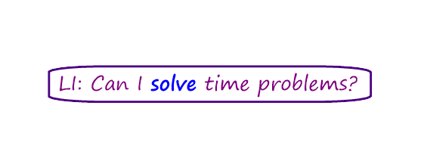

1. We left to drive to the beach at 3:30pm and our journey took 45 minutes.

What time did we get there?

2. Our kickball tournament started at 10:20am and lasted for 2 hours and 15 minutes.

What time did it finish?

3. My friends and I took it in turns to skip yesterday for the skip-a-thon. We started skipping at 12:10pm and skipped for 55 minutes. What time did we stop?

4. I watched a movie that started at 3:30pm. It lasted for one hour and twenty minutes.

What time did it end?

5. I played football with my friends on Sunday. We started at 10:45am and played for 1 hour and 45 minutes.

What time did we finish?

6. I took a trip on a river boat. It left at 9:50am and lasted for two and a half hours.

What time did the trip finish?