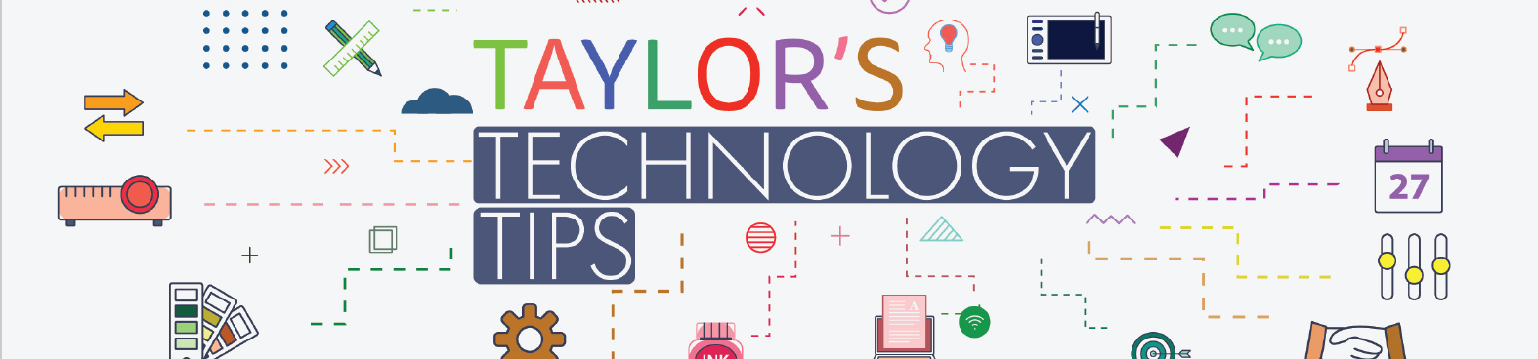

#282 Patana PTG Tech Tips: Accessing PressReader Using your Parents’ Gateway Account

Great news! You can now utilise your Parents' Gateway login credentials to access the Patana Libraries PressReader service. Watch the video below for detailed instructions.

You can also follow these steps on your laptop or desktop; just remember to select the school first. Should you encounter any issues logging into your account, please contact helpdesk@patana.ac.th.

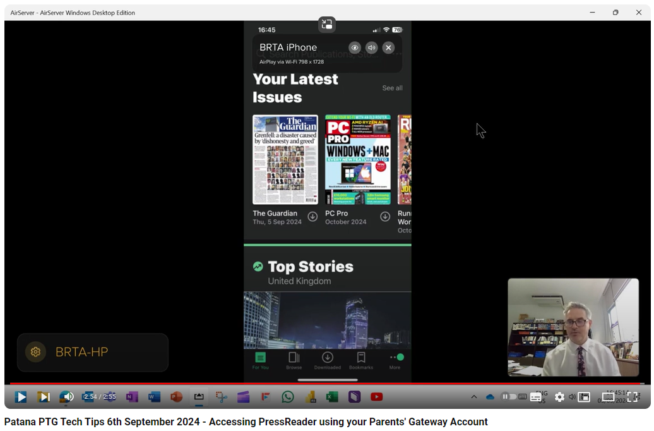

If you have any areas of technology you would like me to talk about in these videos then please add a comment in the video or contact me directly on brta@patana.ac.th.
Have a great weekend.

Brian Taylor
Vice Principal, Technology for Learning

