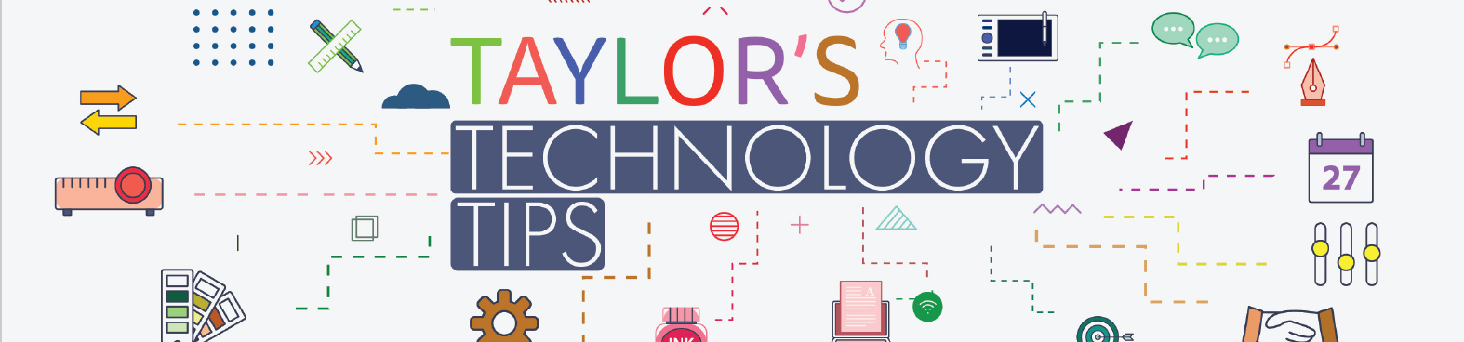

#198: What Parents Need to Know about Apple Guided Access

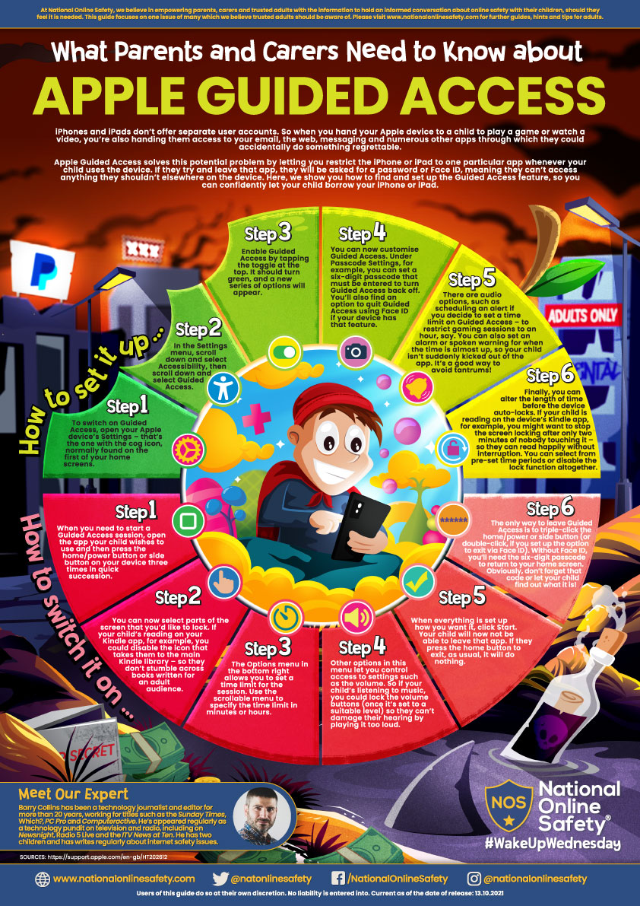

Click the image to download the PDF. Sign up here for more of these parent guides on our National Online Safety App.
Have a relaxing weekend.
Brian Taylor
Assistant Principal, Campus Curriculum Technology Integration

