**#30: Timer Tab and Lumino City**

After a brief hiatus I’m back with my weekly technology tips – I hope you find them useful.

[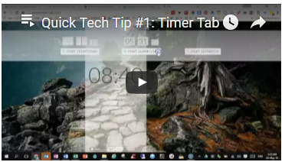](https://www.youtube.com/watch?list=PLWOi-Ohsd2WyLjVU7AidxE0BJuq5doeXn&v=N6ncphpbneA)[Timer Tab](http://www.timer-tab.com/) is super simple timer/countdown/alarm that you can use in the background whilst performing tasks. Useful for students when they are practicing timed assessments for example. I’m sure you can think of many other useful ways in which it can be used. Click the image for a how-to-video-tutorial.

[Lumino City](http://www.luminocitygame.com/) is a BAFTA award winning puzzle adventure game, and the sequel to [Lume](http://www.lumegame.com/). Three years in the making, it's handmade entirely out of paper, card, miniature lights and motors.[](https://vimeo.com/140083355) It’s a fantastic game to play with your children, trying to solve the puzzles you’ll be impressed with both the concept and design. Click the image for a preview and read the [review here](https://www.commonsensemedia.org/app-reviews/lumino-city).

Have a great mindful-tech weekend

**Brian Taylor**

**Assistant Principal, Campus Curriculum Technology Integration**