**Minecraft Logic Gates Worksheet**

**Challenge 1:**

Launch the Minecraft ‘Logic Gates’ world and build each of the gates in the spaces provided.

**Challenge 2:**

Complete the truth tables for each of the following gates.

|  |  |  |  |  |
| --- | --- | --- | --- | --- |
| **AND Gate** | **Minecraft** | **Truth Table** | | |
|  |  | **A** | **B** | **Q** |
|  |  |  |
|  |  |  |
|  |  |  |
|  |  |  |

|  |  |  |  |  |
| --- | --- | --- | --- | --- |
| **OR Gate** | **Minecraft** | **Truth Table** | | |
|  |  | **A** | **B** | **Q** |
|  |  |  |
|  |  |  |
|  |  |  |
|  |  |  |

|  |  |  |  |
| --- | --- | --- | --- |
| **NOT Gate** | **Minecraft** | **Truth Table** | |
|  |  | **A** | **Q** |
|  |  |
|  |  |
|  |  |
|  |  |

**Challenge 3:**

1. In the ‘Build Arena’, build the following gate in Minecraft:  
     
   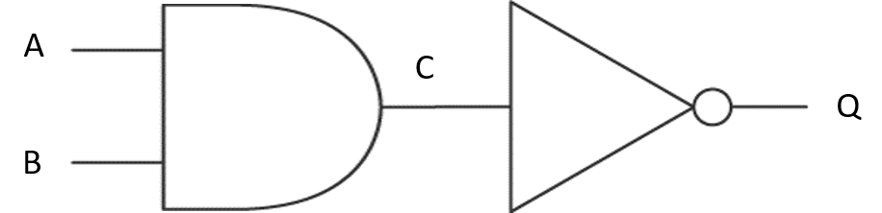

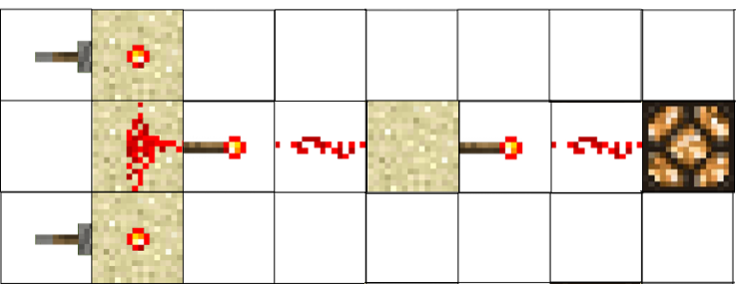

1. Complete the truth table for the above gate:

|  |  |  |  |
| --- | --- | --- | --- |
| **A** | **B** | **C** | **Q** |
| 0 | 0 |  |  |
| 0 | 1 |  |  |
| 1 | 0 |  |  |
| 1 | 1 |  |  |

**Challenge 4:**

Use the build area to create your own logic circuits. Replace the redstone lamp with other redstone powered objects such as doors, pistons or even TNT!