PTG AGM 2024/2025 MINUTES
Tuesday 9th May, 2024 8:00 am Primary Hall

Attendees: Chris Sammons (Head of School), Helen Thew (Cross Campus Principal), Matt Seddon (Secondary Principal), Sarah McCormack (Primary Principal), Cheryl Rego (Development, Alumni and Marketing Manager), Rachel Jones (Head of Admissions), Craig White (Business Development), Safy Rizk (PTG Chair), Pao Tantiprasongchai (PTG Vice Chair), Chris Huang (Secretary), Pook Sapayanon (Treasurer), Soreda Parinyanusorn (PTG Thai Liason), Apollo Chanschrichawla (Primary Rep), Sharan Hora (Secondary Rep), Anchal Pathela (Events), Karina Chattlani (Communications), Chris Chan (Newcomers), and over 150 other parents and staff members

Apologies: Alice Curwood (Cross Campus Assistant Principal Extra Curricular Sports & Activities)

Quorum met

Meeting commenced at 8:13am

Chairpersons Welcome – Safy Rizk

Safy welcomed everyone to the AGM. She mentioned that she was happy to see everyone and that overall it had been a successful year. There was lots of action and PTG was able to proceed with all planned events. Many thanks to all those who participated, namely PTG members and parents, as well as the heads of school for their time, assistance, and support.

Head of School Address – Chris Sammons

Chris reflected on his first year at Bangkok Patana, as well as his journey to get here. He looked at the close relationship the PTG has fostered with the school, and how together they are able to provide a nurturing environment for the students, our children. He sent a thank you to Safy and the other PTG parent volunteers for their time and efforts with the various events throughout this academic year and wished them a safe summer holiday.

Pass 2023/24 PTG AGM Minutes

Anchal motioned to pass the minutes and Apollo seconded.

2023/24 PTG Committee Reports

Tiger Shop Report – Safy Rizk

Sales were at 1.2 million THB
School Departments | - Supported various students projects to be sold at the shop  - Facilitated CAS Layout Design proposal
Secondary Student Involvement | - CAS (Launched in Term 1,2) - 18 students in total  - Worked with Student Groups (Biome, Beeswax ECA, Economist Club)  - Launched 4 more TukTuk Stories - Written By Y9 Student
New Products Launched | 5
AGM targets from

Treasury Report – Pook Sapayanon

PTG started with little over 700,000 THB at the beginning of the year. Revenue highlights from the year included:
- 780,000 THB net income from Fun Day
- Over 500,000 THB net income from the Tigershop
- Over 30,000 THB net income from the Christmas concert
- The funds will help support PTG activities over the next academic year

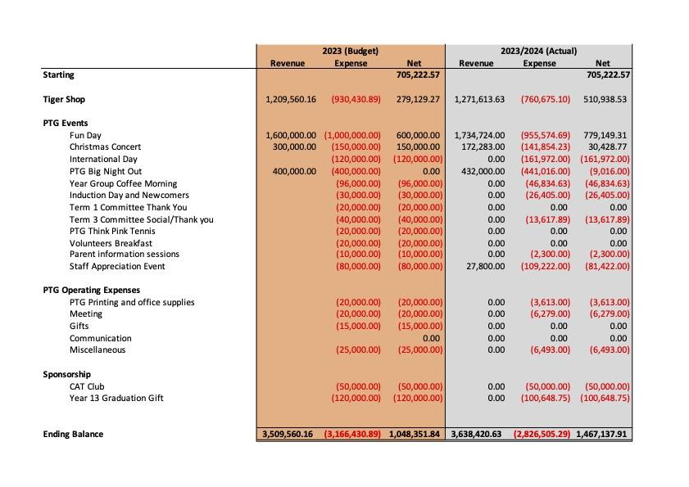

Slide showing the makeup of PTG Revenue and Expenses
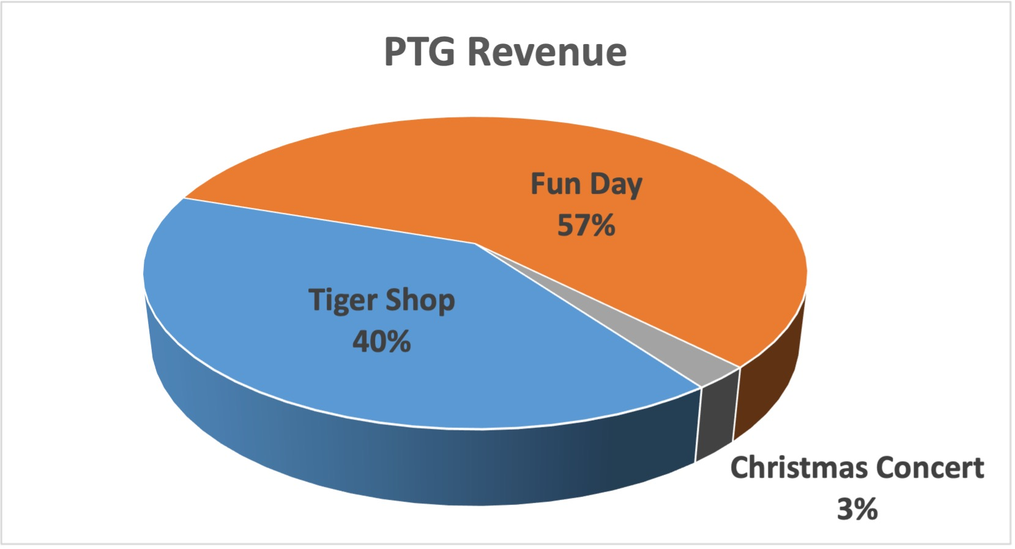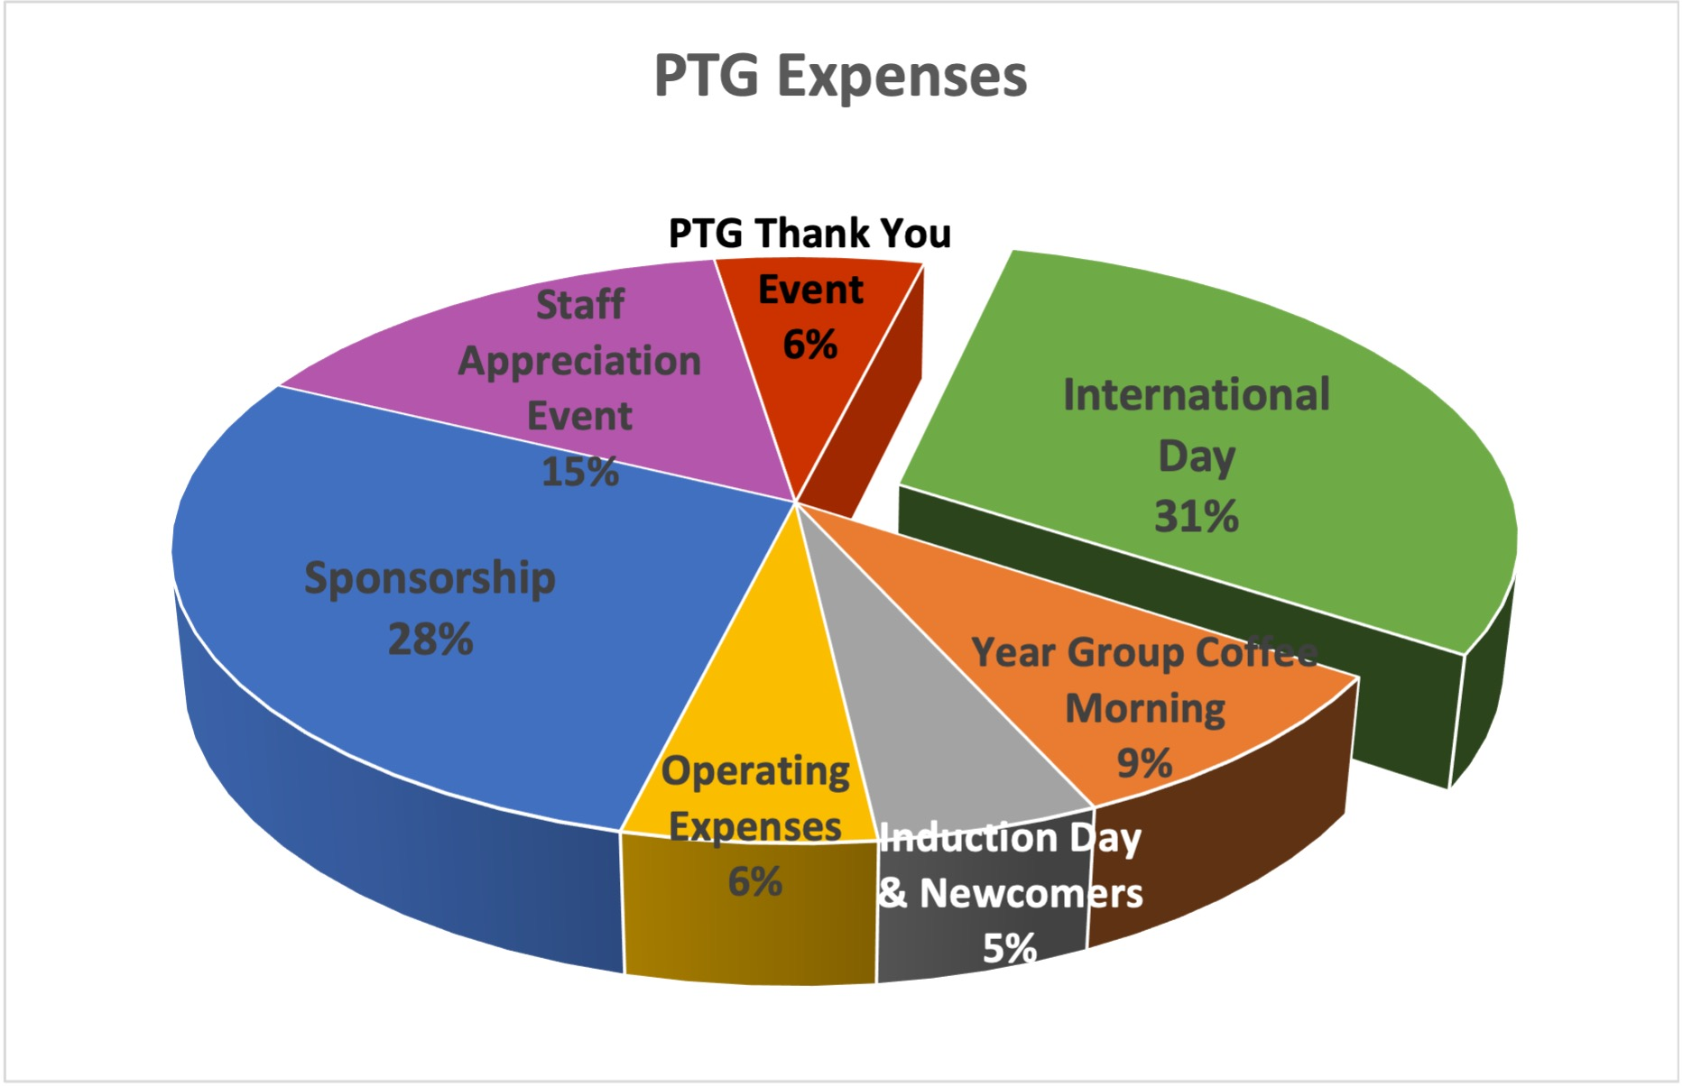

Events Report – Anchal Pathela

Anchal stated that most of the events over the years were already mentioned, and that all 2023/24 events were a big success. She wanted everyone to be aware of the dates for the next academic year:

- Big Night Out – November 9th
- International Day – October 11th
- Christmas Concert – December 11th
- Fun Day – February 10th
- Quiz Night – April/May

Departing Committee Thank you and Farewell

Safy thanked everyone for their time and for coming to the AGM. She asked the departing 2023/24 PTG committee members to come up and be recognized:

Safy thanked all Primary year reps departing for their help and support:
- Treasurer - Rapeepan (Pook) Sapayanon
- FS1 Rep - Pimporn (Pao) Ueno
- FS2 Rep – Asaree (Yuu) Srisongkram
- Year 4 Rep - Maya Hino
- Year 6 Rep - Vanessa Abdala Sales

Nomination and Election of 2024/2025 Committee

Safy called for a confirmation of the nominees up for election from the attendees of the AGM. Each member below was mentioned and gave a brief statement.

Position | Nomination
Secondary Rep | Sharan Hora
Treasurer | Dennis Stech
Tigershop Manager | Sumedha Rawat
FS2 Rep | Napon Eamcharoenying
Year 1 Rep | Pattamanun (Kat) Heeptong
Year 5 Rep | Inna Matijasevich

PTG Chair Election

Cheryl took over to explain the voting process. There were three candidates:
- Safy Rizk
- Teresa Andersson
- Pao Pao Tantiprasongchai

Each candidate was given 30 seconds for a brief statement.

Paper vote ballots would be distributed to those eligible to vote (in the room, attending the AGM) by the four Patana business staff members who were asked to assist with the AGM voting process. Once ballots are distributed and voters have marked their choice on their ballot, they were to place ballots in one of four ballot boxes at the table at the front of the room, located in front of the business staff members.

PTG Exec members are allowed to present a maximum of two (2) proxy vote forms. Once verified by the business staff members that these forms are completed in its entirely, a ballot will be given to said PTG exec member for each complete proxy form. At that point the PTG exec member would be able to cast and deposit their ballots in the boxes.

Once the proxy votes were completed, Cheryl proceeded with the general vote. Business staff members distributed paper ballots to all those eligible voters in the room and noted that votes can only be cast once all voters received ballots. Votes were allowed to be cast in a fifteen-minute window (9:15-9:30a IST). Those who were not present when the initial ballots were passed out were given ballots if they appeared in the 15-minute voting window and were deemed eligible to vote by the business staff.

After the voting window ended, the business staff proceed to count the ballots in plain view of those in attendance. Business staff members announced that Safy Rizk had received the most votes.

Close of Meeting

Cheryl thanked everyone for attending and their participation in the AGM voting process. She gave a special thank you to Chris Huang for his work taking roll call and minutes for the AGM.
Safy also thanked everyone for attending.

Meeting adjourned at 9:59 am

