Age  Category | Common Sense Media Lesson | Resources | Curriculum Opportunities
Year 5  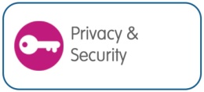 | Lesson 1  Strong Passwords  Pupils learn how to create secure passwords in order to protect their private information and accounts online. | Digizen - Perfect passwords  Teacher’s resource and activities  Budd:e - Password Power  Lesson plan  Microsoft - Password checker  Password security checking tool  Netsmartz - Password Rap  Video  Roboform - How secure is my password?  Password strength checking tool  Roar Educate - Cooking up Passwords poster | ICT: Communicating information  Use a range of ICT tools to present information in forms that are fit for purpose, meet audience needs and suit the content.  English: Writing  Develop ideas, themes, imagery, settings and/or characters when writing to imagine, explore and entertain.  Idea: Create storyboard, script and animation short to communicate ‘Do’s and don’ts for passwords’ for an identified audience (parents or pupils). You could use software such as J2e spotlight, digital blue movie creator, or an online tool such as goanimate

Age  Category | Common Sense Media Lesson | Resources | Curriculum Opportunities
Year 5  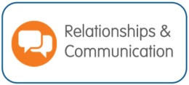  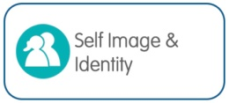 | Lesson 2  Digital Citizenship Pledge  Pupils work together to outline common expectations in order to build a strong digital citizenship community. Each member of the class signs a We the Digital Citizens Pledge. | Cybersmart – Positive Online Communications  Teachers resources  UK Safer Internet Centre – Connect with Respect - Safer  Internet Day 2013 resource pack  BBC – Beaker You Choose – videos about positive choices | ICT: Impact of technology - exploring how ICT changes the way we live our lives and has significant social, ethical and cultural implications.  Communication and collaboration -exploring the ways that ICT can be used to communicate, collaborate and share ideas on a global scale, allowing people to work together in new ways and changing the way in which knowledge is created.  Idea: Establish or further develop a class online community perhaps using the school learning platform, or an online resource like thinkquest.org  Utilise the community to support cross curricular or wider school community activities such as a fund raising activity, or a sports or performance event.  Review the effectiveness of the community, the need for establishing ground rules and positive practices.

Age  Category | Common Sense Media Lesson | Resources | Curriculum Opportunities
Year 5 | Lesson 3  You’ve Won a Prize  Pupils learn what spam is, the forms it takes, and then identify strategies for dealing with it. | Cybersmart – Don’t be fooled  Teachers resources  BBC – Lady Jane Grey – “beware what you download “  Horrible histories video  Netsmartz – Router’s Birthday Surprise  Teacher notes and video  Roar Educate - Bug Catcher poster  Roar Educate - Can the spam poster  Mediasmart – Be Adwise | English: Composition  Plan their writing by noting and developing initial ideas, drawing on reading and research. Perform their own compositions, using appropriate meaning and intonation so that meaning is clear.  ICT: Working with others to explore a variety of information sources and ICT tools e.g. using ICT tools to capture and change sounds.  Reviewing modifying and evaluating work as it progresses  Review what they and others have done to help them to develop their ideas.  Idea: Create a ‘Spam Spotters’ radio jingle. Locate and use appropriate sounds, for example Audio Network, you could try editing sounds using a tool such as audacity.

Age  Category | Common Sense Media Lesson | Resources | Curriculum Opportunities
Year 5  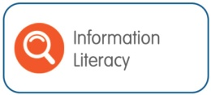 | Lesson 4  How to Cite a Site  Pupils reflect on the importance of citing all sources when they do research. They then learn how to write bibliographical citations for online sources. | Wikihow - Cite a site  Teacher resource – how to acknowledge a source of information appropriately  Google – Search Literacy Useful tips on searching | ICT: Communication and collaboration  exploring the ways that ICT can be used to communicate, collaborate and share ideas on a global scale, allowing people to work together in new ways and changing the way in which knowledge is created, whilst acknowledging sources.  Idea: Using sound and screen-recording software, such as Camtasia, each pupil produces a film of favourite sites to support home learning, with talk-over of why these sites are relevant, useful and learning-friendly. Finished films can be uploaded to blog sites or Youtube to support future learning.

Age  Category | Common Sense Media Lesson | Resources | Curriculum Opportunities
Year 5  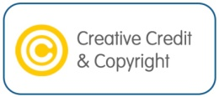 | Lesson 5  Picture Perfect  Pupils learn how photos can be altered digitally. They will consider the creative upsides of photo alteration, as well as its power to distort our perceptions of beauty and health. | Mediasmart - Body Image Lesson  Resource for 10 – 11 year olds - explores the idea of body image online  BBC – Saxon Monk – Internet Videos are Forever – Horrible Histories video | PSHE: Personal identities  Understanding that identity is affected by a range of factors, including positive sense of self.  Idea: “Who am I in the E-world?”  Pupils could perform as role-play/drama, or create online presentation using Online sharing tool such as Animoto. If pupils do not have an online presence, then they could design them – what would their gaming tag be? What would their avatar look like? How might they use images in games in social networks etc?

