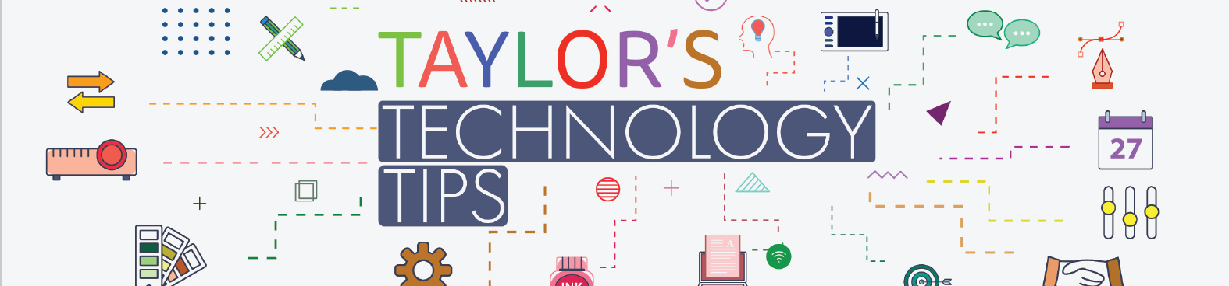

#275 Patana PTG Tech Tips: Text Replacement Shortcuts & Talking to Your Kids About A.I.

If you have any areas of technology you would like me to talk about in these videos then please add a comment in the video or contact me directly on brta@patana.ac.th.
Note: A.I. tips courtesy of Common Sense Media for Families.

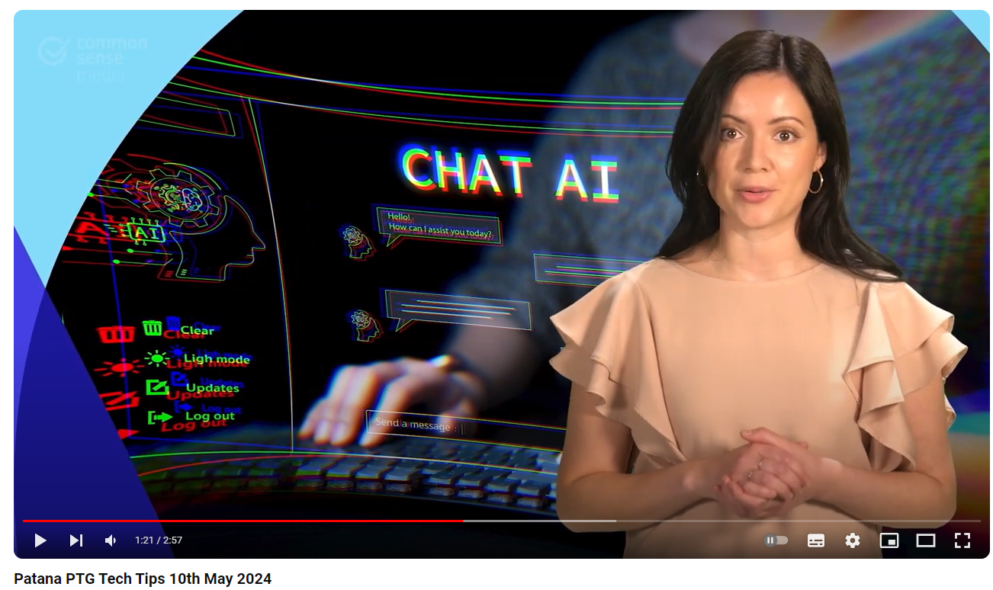

Timestamps

0:00 #1 Text replacement shortcuts on your phone
1:14 #2 Five tips for talking to your kids about A.I.

Have a great weekend.

Brian Taylor
Assistant Principal, Technology for Learning

