
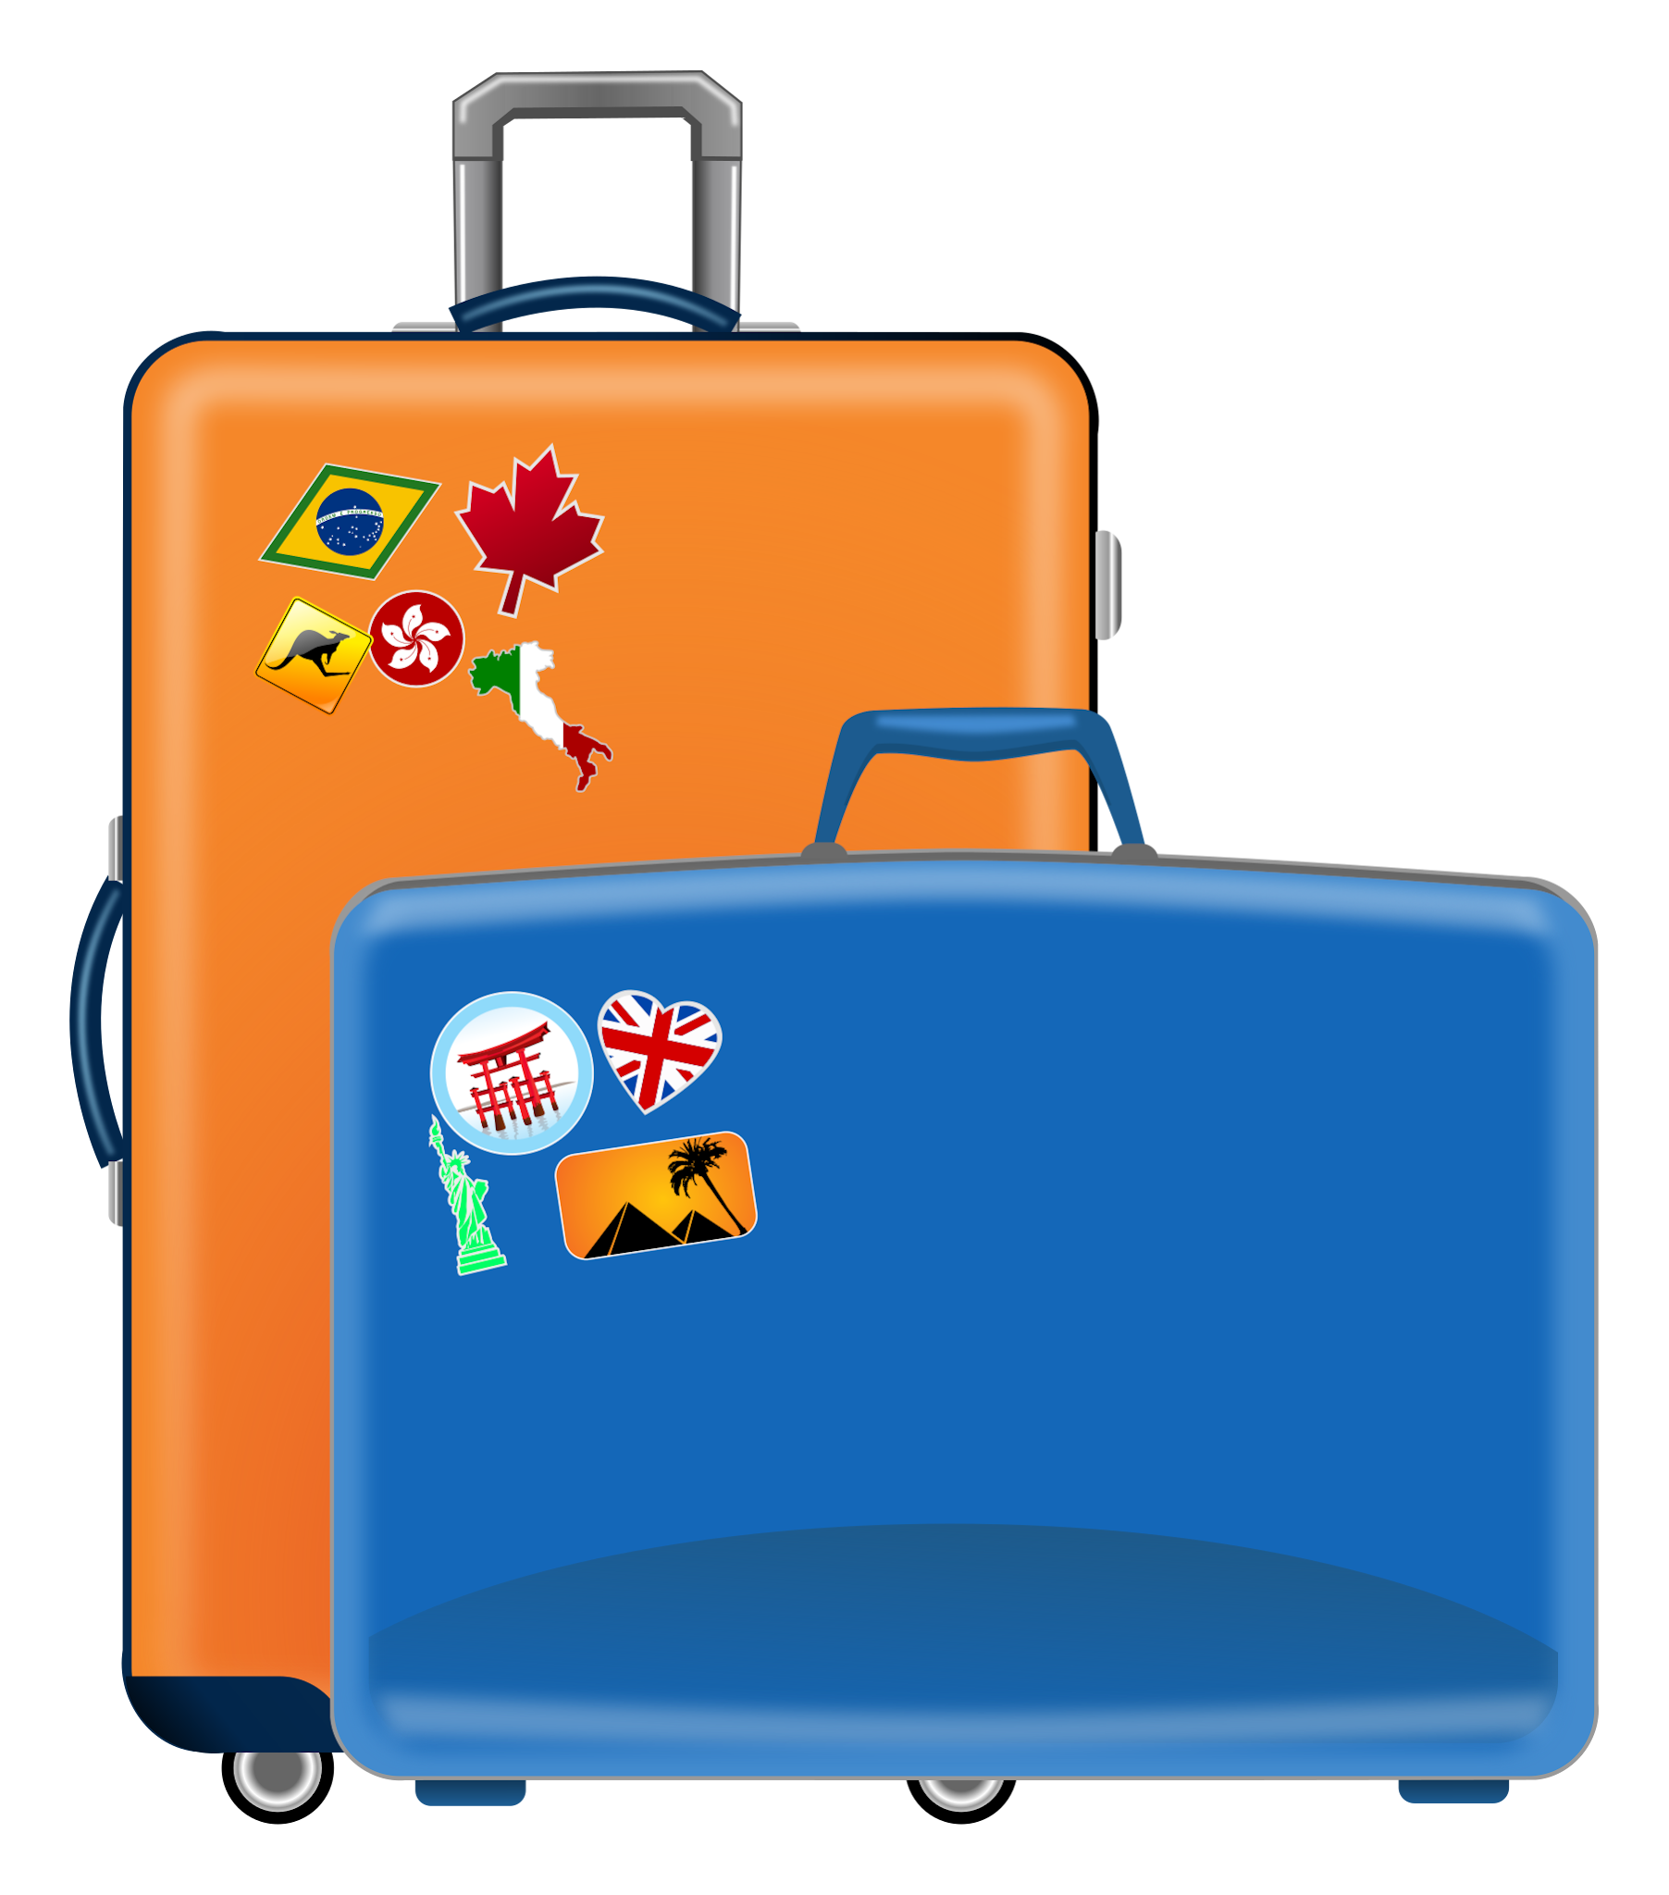

Y3 Residential packing list

PACKING LIST: Please label all belongings with name and class code.
Please help your child to pack their small duffel bag or small wheelie case.
Students should be able to identify their own belongings and carry their own bags.

- 2 pairs of shorts
- 4 T-shirts
- 4 pairs of socks
- 4 pairs of underwear
- 1 pair of long trousers or jogging pants
- Sandals/flip flops
- Trainers or comfortable shoes suitable for activities
- Change of smart clothes for dinner
- Sweatshirt
- Pyjamas/nightdress
- Swimsuit, goggles and towel (sun tops)
- Plastic bag for dirty laundry
- Toiletries packed in a toilet bag (including mosquito repellent)
- Sunglasses and sun cream
- Reading or puzzle books
- A torch (not essential)
- Favourite comforter for bedtime – teddy bear, blanket etc.
- Small backpack for the picnic
- Reusable water bottle
- Hand gel

