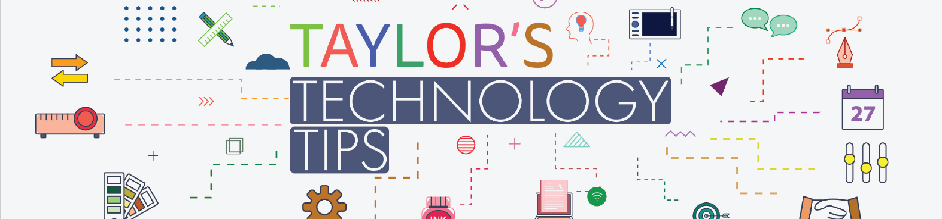

#306: How LLMs Can Help You Find Cheap Flights
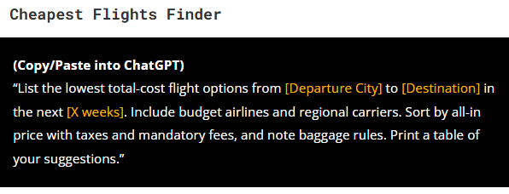
Image courtesy of: How to Use ChatGPT to Find Cheap Flights (Airlines Hate This!)

In a world where airlines seem determined to squeeze every penny from travellers, a clever use of Large Language Models (LLMs) eg ChatGPT, Copilot, Claude, Gemini, Perplexity etc, might just be the secret weapon students and families need. A recent guide by Nick Smith outlines eight powerful prompts that can help users uncover the cheapest flight options without relying on loyalty programmes, VPNs, or complicated hacks.
From scanning for the lowest fares across flexible dates to identifying multi-layover routes under budget, these prompts turn AI chatbots into a savvy travel assistant. Users can even request breakdowns of hidden fees, generate refund comparisons, and draft persuasive emails for price matches or upgrades. One particularly intriguing prompt explores “hidden-city ticketing”—a controversial method that can reduce fares but comes with risks.

While the most advanced features work best with paid plans, even free users can benefit with a bit of manual effort. The article encourages readers to experiment, share their wins, and save money for more exciting parts of their journey—like the destination itself.

For tech-savvy students planning holidays or school trips, this is a smart, accessible way to stretch travel budgets further. Just prompt, plan, and fly smarter. I used the prompts to find a direct flight back to London for just $173.

Have a great half term!

Brian Taylor
Vice Principal, Technology for Learning

