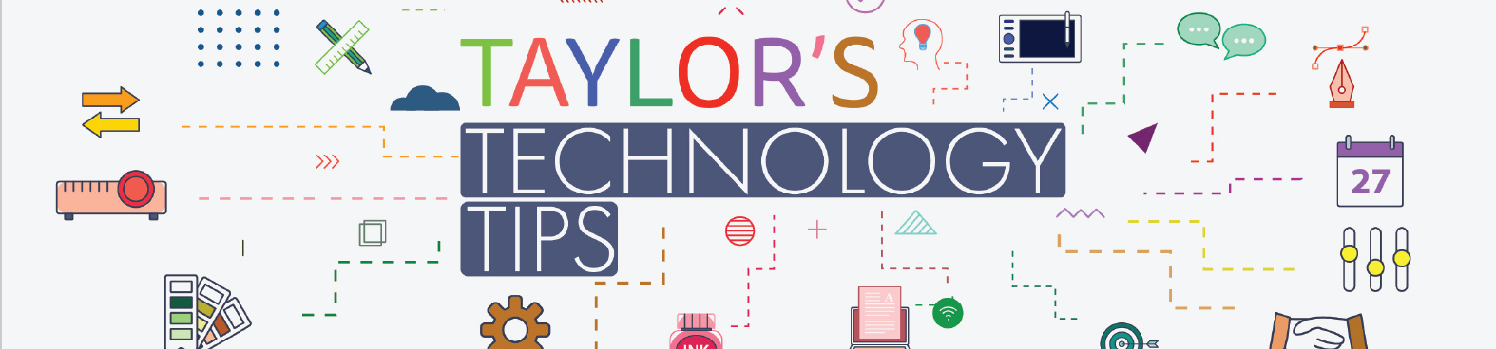

#207: What Parents Need to Know About YouTube

YouTube, the omnipresent video-sharing social media platform, allows billions of people around the world to watch, share and upload their own videos with a vast range of content – including sport, entertainment, education and lots more. It’s a superb space for people to consume content that they’re interested in. As a result, this astronomically popular platform has had a huge social impact: influencing online culture on a global scale and creating new celebrities. In the guide, you'll find tips on a number of potential risks such as connecting with strangers, inappropriate content and high visibility. I hope you find it informative

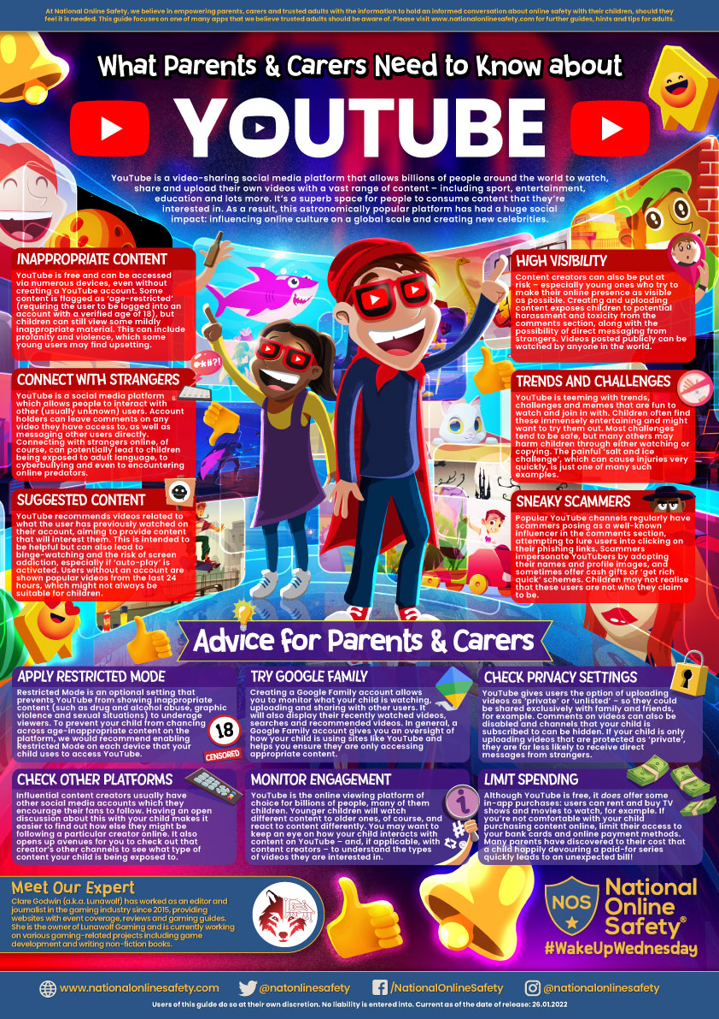

Have a relaxing weekend.

Brian Taylor
Assistant Principal, Campus Curriculum Technology Integration
Have a great weekend.
Brian Taylor
Assistant Principal, Campus Curriculum Technology Integration

