Ready to start packing?

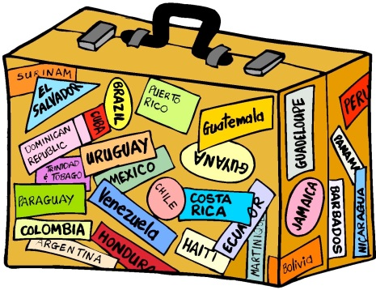Here’s a helpful list….

* 2 pairs of shorts
* 4 T-shirts
* 4 pairs of socks
* 4 pairs of underwear
* 1 pair of long trousers or jogging pants
* Sandals/flip flops
* Trainers or comfortable shoes suitable for activities
* Change of smart clothes for dinner
* Sweatshirt
* Pyjamas/nightdress
* Swimsuit and towel
* Plastic bag for dirty laundry
* Toiletries packed in a toilet bag (including mosquito repellent)
* Sunglasses and sun cream
* Reading or puzzle books
* Favourite comforter for bedtime – teddy bear, blanket etc.
* Small backpack for the picnic
* Rash Vest for pool/beach
* Named Water Bottle

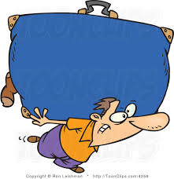

Remember... your bag must not be too big. Make sure you’re able to carry it!!