**Intelligent Searching**

**What is the internet?**

The internet is a way of computers talking to each other! It is a vast network of millions of computers across the whole world. They talk to each other by using addresses called IP addresses. Each IP address is a collection of numbers which also has an address in words too like [www.hotmail.com](http://www.hotmail.com).

When you go to a webpage your computer sends a message to the address of that webpage and then it replies with the information you need. The message does not go directly it goes through your router, your broadband provider and via lots of other computers. The end.

**What is a search engine?**

It's possible to think of the internet as the world's biggest library - but instead of books, its shelves contain billions of individual web pages.

Imagine being in such a vast library. It would take forever to find what you were looking for!

**Find websites fast**

Search engines are special websites that have indexed billions of pages - and make it easy for you to find a website or page in an instant. Popular search engines include Google, Yahoo!, Bing and Ask.

**Using key words**

If you wanted to search for days out in London, you could type **London days out** into the search box and then either press 'Enter', or click on 'Search' or the search symbol (which can be a magnifying glass).

You'll get a list of the most popular web pages that contain the words you typed in.

You could search again using more key words. So instead of just **London days out**, you could add the word kids. Now your search results should give you pages relating to days out in London that kids might enjoy.

You can keep on adding more key words to narrow down your search results further.

**So, just be aware that not all search results are based on the popularity of a site.**

**Sensible Keywords**

1) Which pharaoh ruled Egypt for the longest period of time?

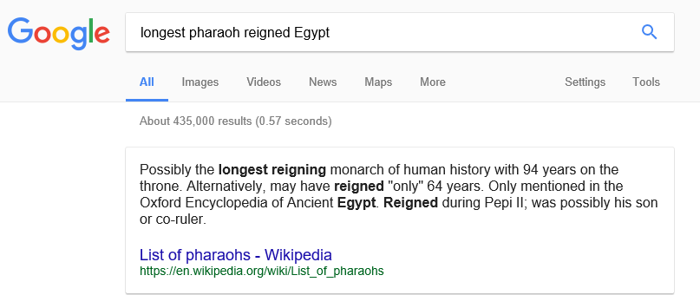

2) When and where do British Swallows migrate to? What route do they take?

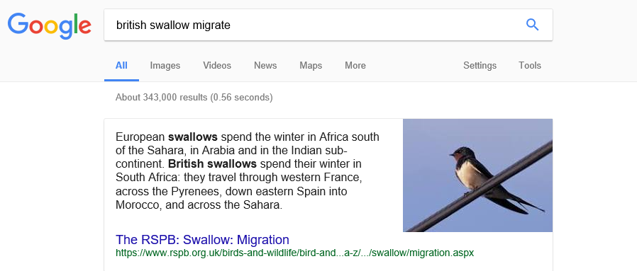

3) Where does the Arctic Tern migrate to and from? How many return trips to the moon could the Turn do in its lifetime based on its migration distance travelled?

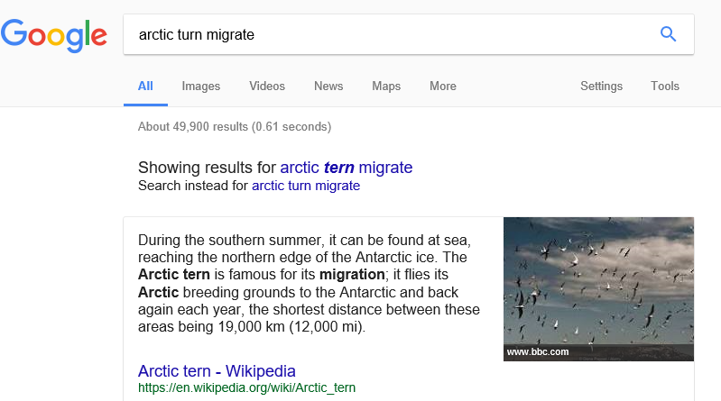

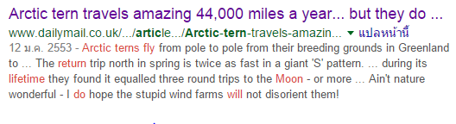

**What would my life be like without the internet?**

1. I would have to look in books for the answers to questions I did not know.
2. I would have to use a paper map to find places without Google maps
3. I could not play computer games with people around the world.
4. I could not skype my parents in England I would have to call them on the phone

**Google Advanced searching**

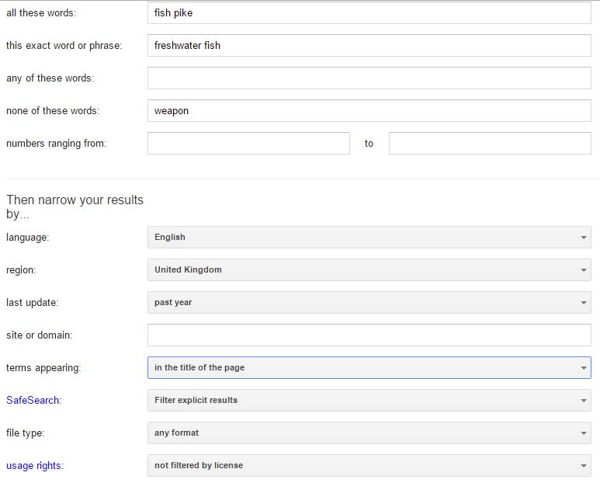

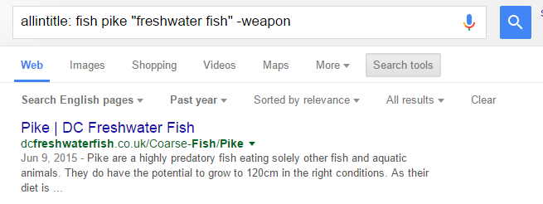

### **Google Operators**

### ../Screen%20Shot%202017-09-26%20at%2011.27.06.png

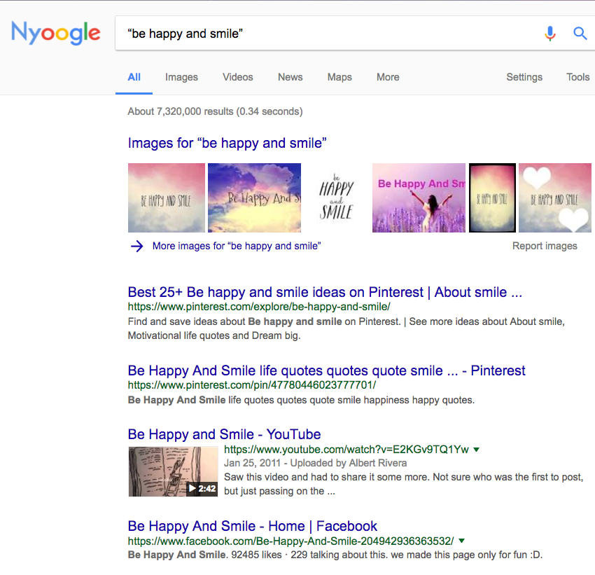

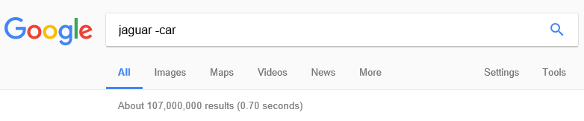

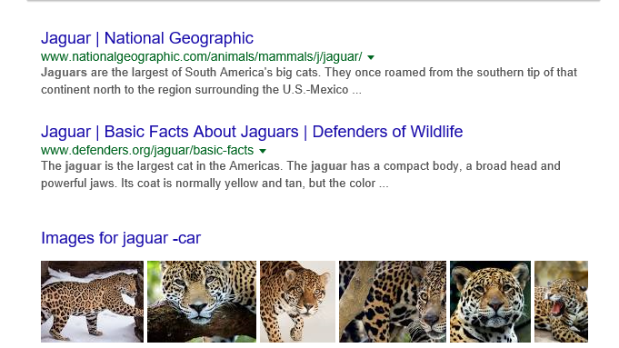

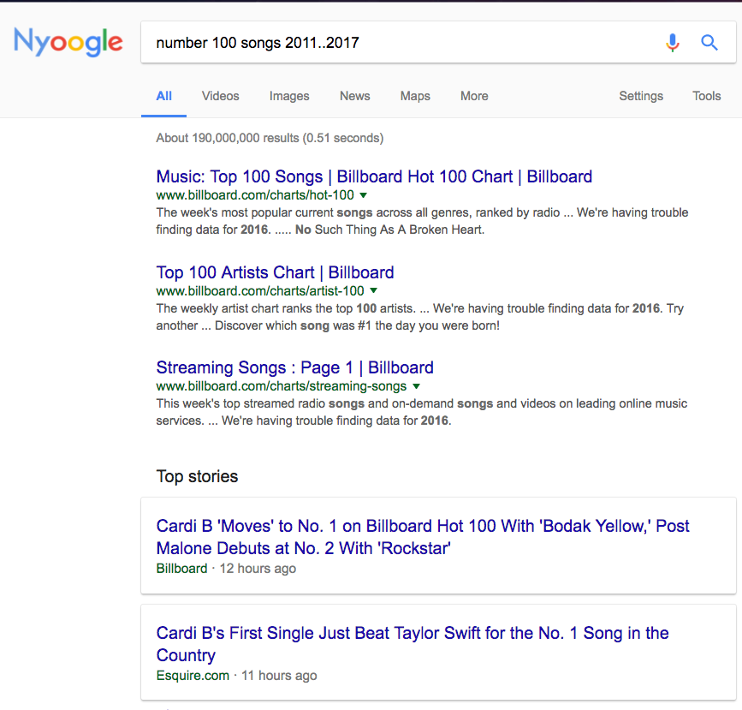

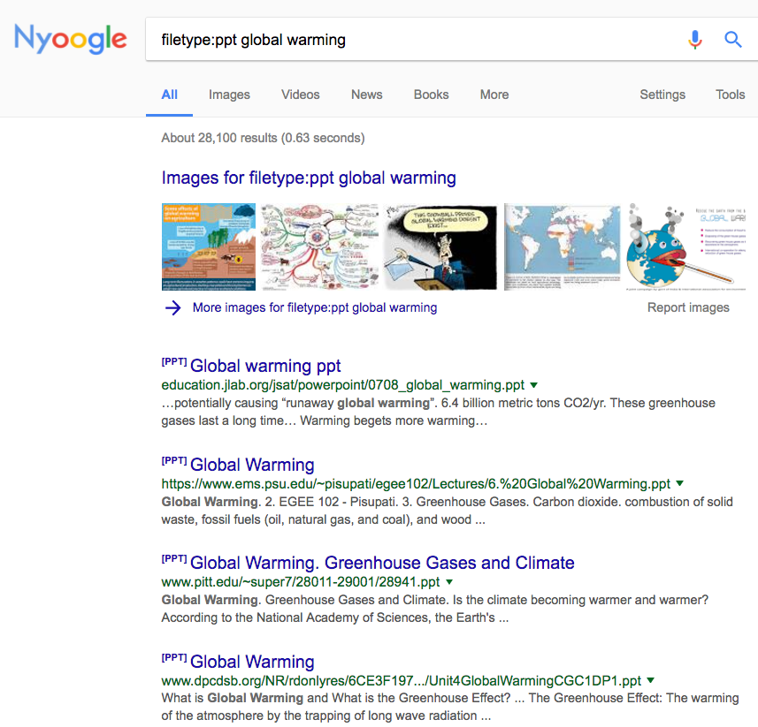

**Which Google operator will I use most?**

I think I will use the filetype search to find useful documents from my learning.

**FAKE NEWS**

Fake news is news that you can’t rely on. It is all over the internet as people want you to click on it to go to their websites. They often try and make sensational claims “**Did you see what Justin Bieber did last night?”** you might think it is real but when you click on it there is no real story or they have made something up. People do this to make money, the more people they can get to click onto their websites the more they can sell advertising for.

**TIPS**

1. Has the story been reported anywhere else – Check other websites?

2. Is it on the radio, TV or in the newspapers?

3. Have you heard of the organization that published the story?

4. Does the website where you found the story look genuine? (meaning it doesn't look like a copycat website that's designed to *look*like another genuine website)

5. Does the photo or video look normal?

6. Does the story *sound*believable, use your common sense?

**Discriminating between reliable and unreliable sources**

Sir Francis Drake Questions

1) Sir Francis was born in 1545.

2) The nick name he was called by the Spanish was El Draque meaning The Dragon.

3) He died near Panama because of a fever. He was on a voyage to attack Spanish colonies in West Indies.

Our answers are not the same.

This is how we checked for reliability to see whose website was reliable and whose was unreliable:

We searched on 2 other websites to compare information:

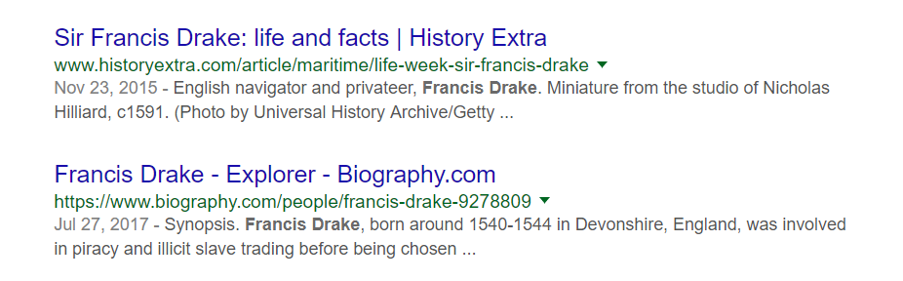

We then googled the websites with the word reliable next to it:

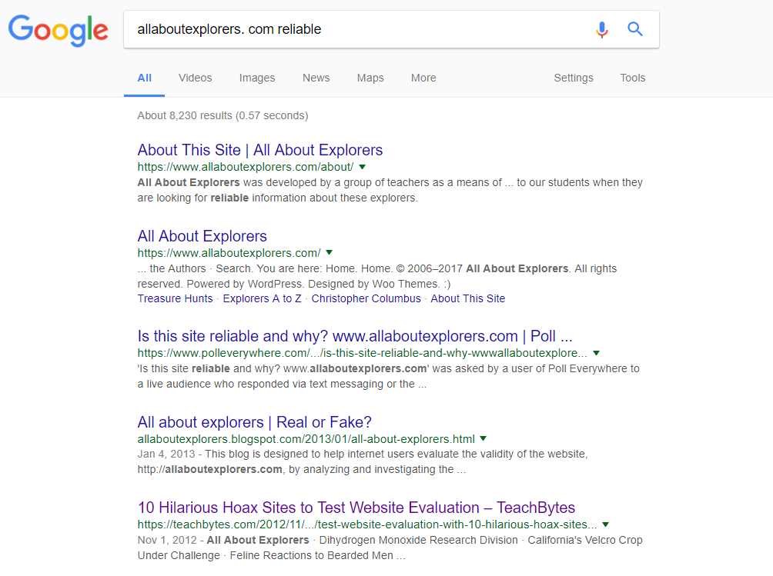

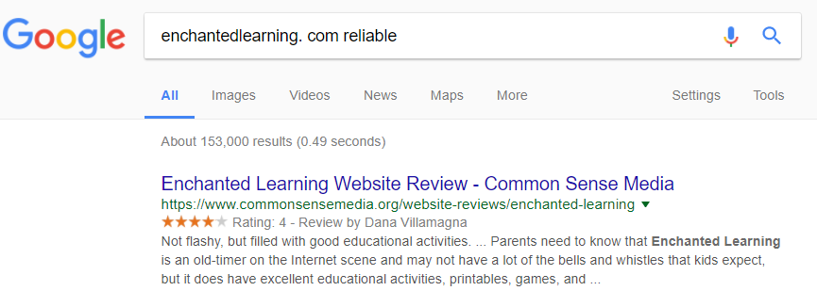

These checks showed us that All about explorers was the unreliable site and the Enchanted learning site was reliable.