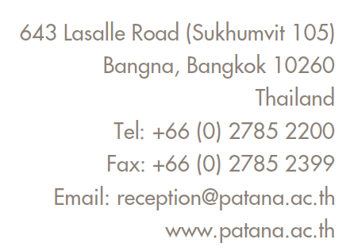

2nd December 2024

Dear Parents and Carers,

The deadline for our annual Christmas Book Collection is fast approaching! We kindly ask that you send in an unwrapped new book in Thai for our friends at Grapongdeang School in Khlong Toey. We will be delivering the books in person during the final week of term.

Thank you so much for your support and generosity!

Warm regards,

The Year 1 Team

