

#284: Hide Apps in iOS 18
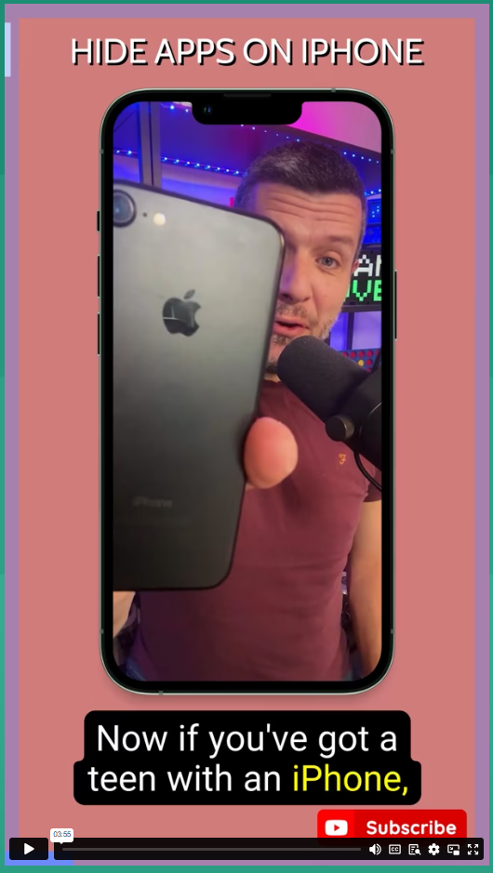
The latest iOS 18 release allows apps like TikTok, Instagram, and Snapchat to be hidden in a secret folder—making them invisible on the Home Screen and even from the search bar. As parents and caregivers, it’s more important than ever to keep up with these updates so we can guide our children safely through the digital world.

If you want a step-by-step guide on how to find hidden apps and more, watch Wayne Denner explain it for you by clicking on the image.

Key Takeaways:

- Set up and use parental controls where possible—Apple’s ‘Ask to Buy’ feature is a great start.

- Hidden apps can still be tracked via Screen Time, battery health, and App Store purchases—keep an eye on these!

- Open, ongoing conversations about digital safety are key. Explore tech together and set boundaries.

Hope to see you at the Fun Run!

Brian Taylor
Vice Principal, Technology for Learning

