

#285: New Parental Controls in Fortnite: Time Limits & Time Reports

You can now manage the amount of time your child spends in Fortnite and Unreal Editor for Fortnite (UEFN) using our new Time Limit Controls. You will now see an option to set up time limits for your child’s account in the Parental Controls section in the Fortnite main menu, or on the Epic Account Portal on the web. If you choose to enable this parental control, you can:
- Limit the total amount of time your child can play per day.
- Choose specific time windows when your child can play each day, and set time limits within that window.
- Choose whether to allow your child to request more time as they approach the end of their time limit.

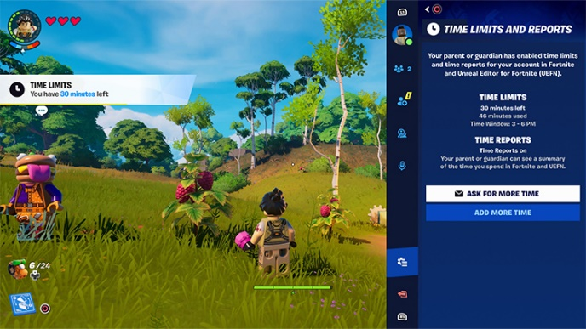
From Epic’s Account Portal, parents/guardians can sign into their child’s account to set up time windows and a total time limit. If you set up a time limit, your child will begin seeing in-game notifications when they have 30 minutes left in Fortnite and UEFN. Once your child reaches their limit, they will not be able to use Fortnite or UEFN until the next day or until a new window begins.

If you have allowed your child to request more time, and they have 30 minutes or less left in their window, your child can request more time from within Fortnite. Their request will send you an email with a link where you can add more time for that day if you choose. You can also add more time, even if you haven’t enabled requests for more time, from inside Fortnite by going to the Time Limits and Reports Sidebar and selecting “Add More Time”. Once you input your Parental Controls PIN code, you can select the desired increment of time to add. Time granted will be effective immediately.

Your child can request more time by going to the main menu in Fortnite, selecting “View Time Limits,” then choosing “Ask for More Time” if you have this setting turned On. Time Limit Controls work across consoles and devices. As long as your child is using the same account across devices, the limit you set will be in effect for Fortnite and UEFN no matter where they play or create.

You can turn on Time Reports within the Parental Controls section in the Fortnite main menu, or on the Epic Account Portal on the web. If you’ve opted into Time Reports, you can view the total time your child has spent in Fortnite and UEFN that week. You will also have access to a dashboard located in the Account Portal, which provides a daily breakdown of time spent in Fortnite and UEFN and indicates when you have granted extra time for your child. Whenever you go back to the Account Portal, you will be able to see up to four weeks of activity (or less if you haven’t had Time Reports enabled for that long).

Parents will continue to have the option to receive weekly Time Reports emails. These emails include a summary of the amount of time your child spends in Fortnite and UEFN and are sent to the parent or guardian linked to the child’s account. To view and manage your child’s Parental Controls, sign in to your child's Epic Games account on the web or within Fortnite and go to Parental Controls.

For information about Epic’s Parental Controls, visit the Safety and Security Center.

Brian Taylor
Vice Principal, Technology for Learning

