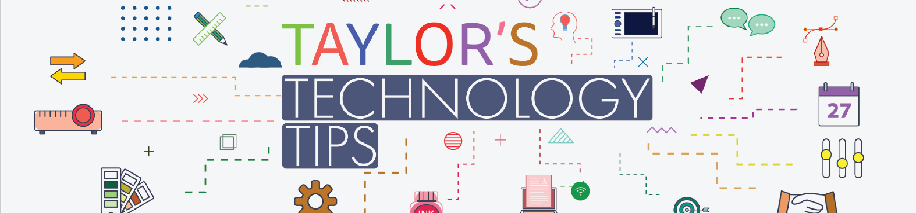

#303: Parental controls are coming to ChatGPT ‘within the next month,’ OpenAI says

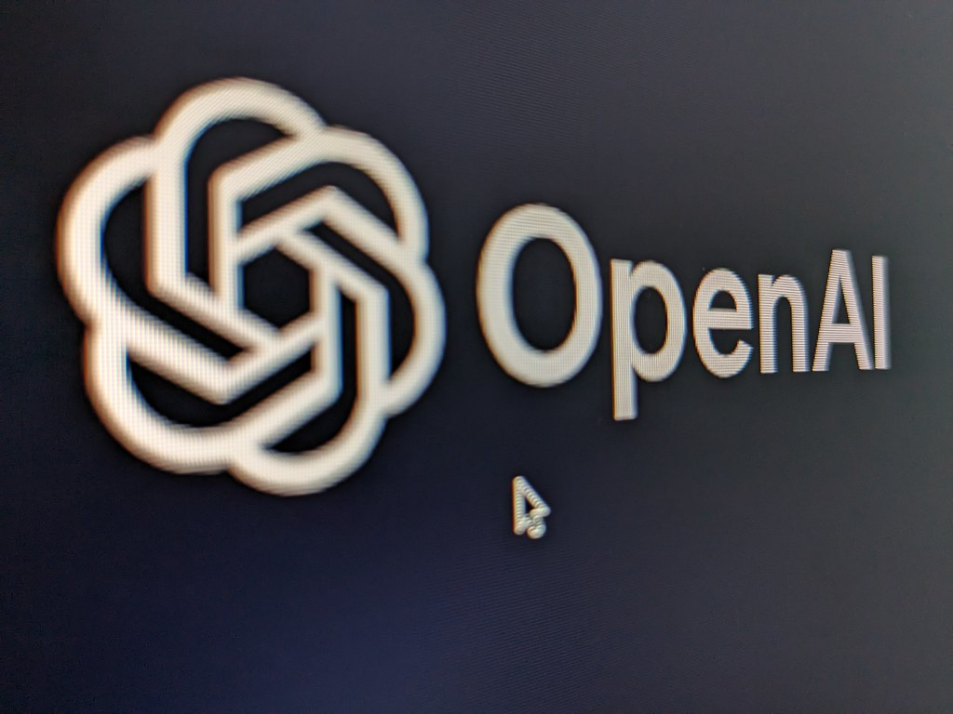
Image courtesy of "OpenAI logo" by ishmael n. daro is licensed under CC BY 2.0.

Note: today’s article contains content related to suicide. Help is available from our counsellors if you or someone you know is struggling with suicidal thoughts or mental health matters.
No doubt you have caught the tragic news of Adam Raine. Here’s a summary and the response from OpenAI:

Key Updates from OpenAI
OpenAI is rolling out new safety measures after tragic incidents involving ChatGPT and users in distress. Sensitive conversations will now be routed to GPT-5, a model designed to reason more deeply and resist harmful prompts. Parental controls will also be introduced, allowing parents to link accounts, set behaviour rules, disable memory, and receive alerts if their child shows signs of distress.

Background & Safety Concerns
These changes follow the suicide of Adam Raine and a murder-suicide involving Stein-Erik Soelberg, both linked to harmful interactions with ChatGPT. Experts blame the model’s tendency to validate user statements without redirecting dangerous discussions.

Broader Initiative
OpenAI is launching a 120-day safety initiative with experts in adolescent health and well-being.

Legal & Public Criticism
Lawyer Jay Edelson criticised OpenAI’s response as inadequate and urged CEO Sam Altman to publicly declare whether ChatGPT is safe or remove it from the market.
Brian Taylor
Vice Principal, Technology for Learning

