

#197: Technology For Learning Weekly Review


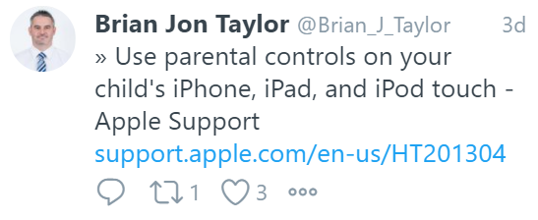
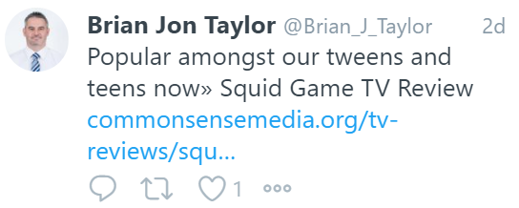

Find below some of the highlights of my digital travels this week.
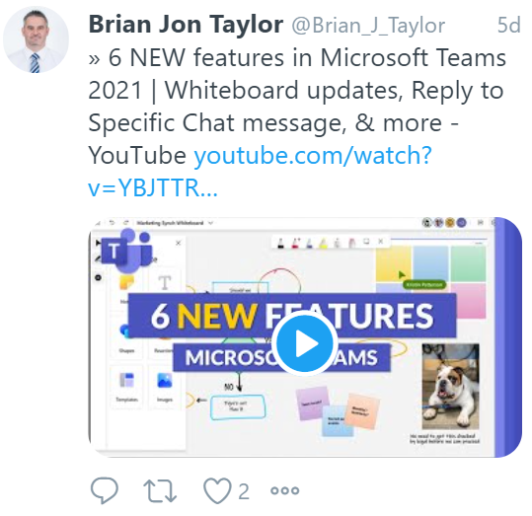

Have a wonderful weekend.
Brian Taylor
Assistant Principal, Campus Curriculum Technology Integration

