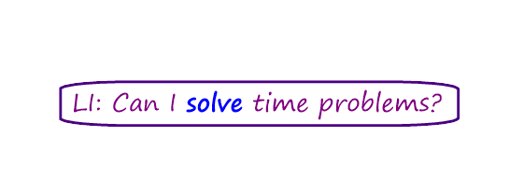



1. I watched a movie that started at 3:30pm and finished at 5:00pm.

How long did the movie last?

2. I helped my parents tidy up the house on the weekend. We started at 9:00am and finished at 11:30am. How long did we spend tidying?

3. We had a kickball match against 3H last Tuesday. We started at 10:30am and finished at 11:30am. How long did our match last for?

4. I went shopping on the weekend. I left home at 11:30am and got home at 1:00pm. How long did I spend shopping?

5. Our school day starts at 7:30am and finishes at 2:30pm. How long is the school day?