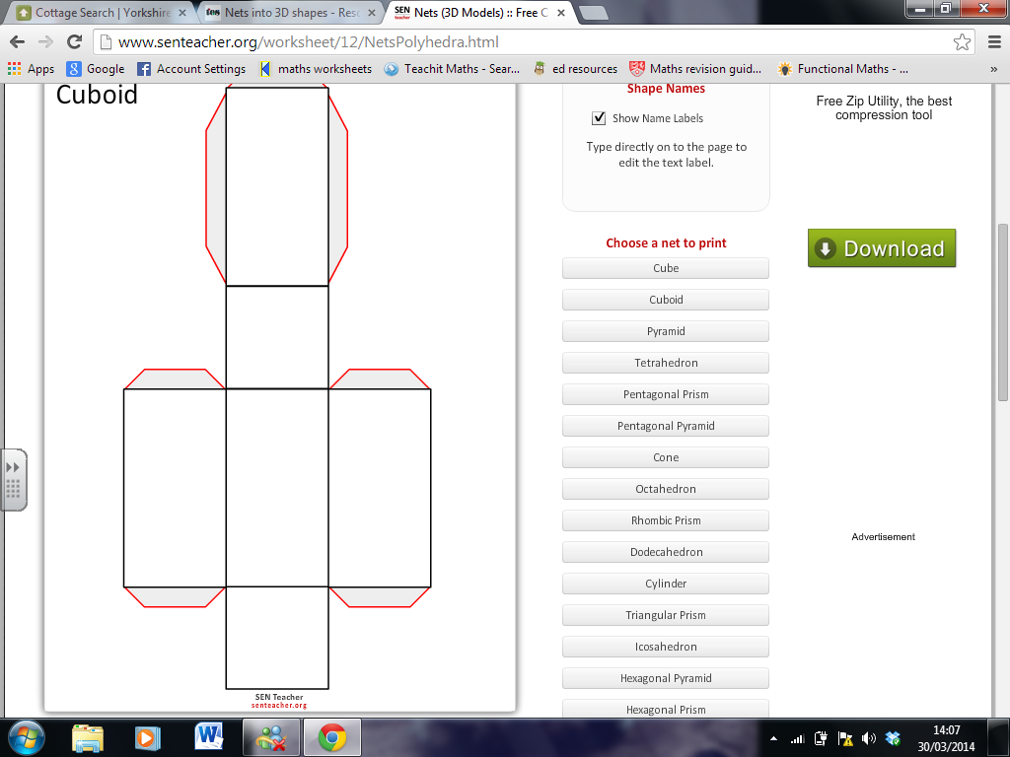

6

5

1. Cut out along the outline of the shape.
2. Fold along the black lines.
3. Punch a hole next to each number.
4. Place string through the holes in

ascending order

(keeping hold of the other end).

1. Tie both ends of the string together.
2. Pull the string to create your 3D shape

8

7

4

3

2

1