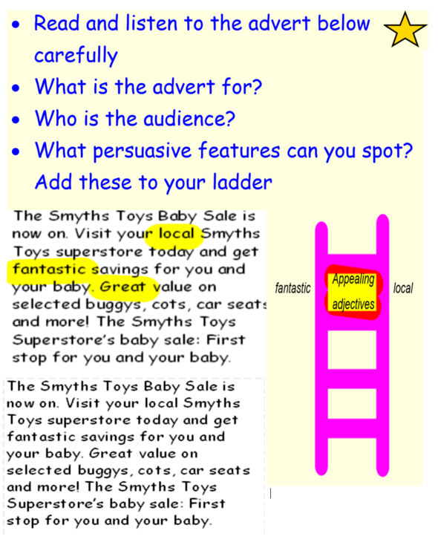

<https://www.youtube.com/watch?v=oOR_lSQUE0s>

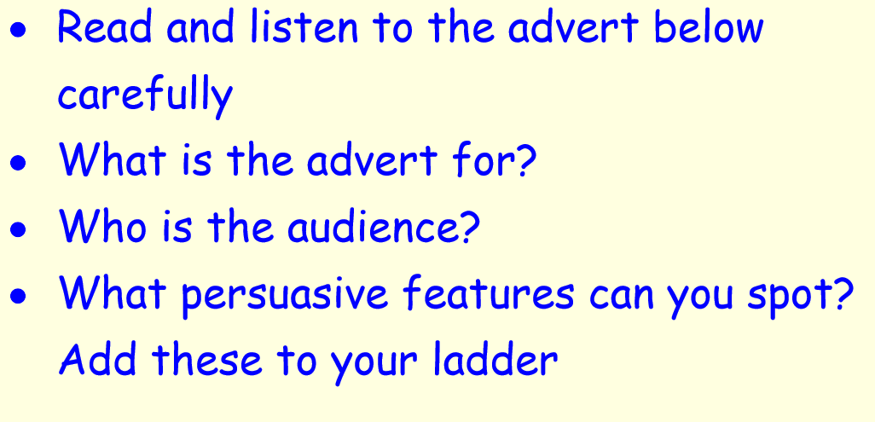

<https://www.youtube.com/watch?v=g86RPUZNbB0&index=6&list=PLHUaaykOvA9fzyuC5UuD5YX6VYjJrUTGR>

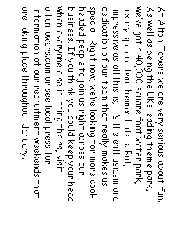



<https://www.youtube.com/watch?v=yRODqCQqBjw&list=PLHUaaykOvA9fzyuC5UuD5YX6VYjJrUTGR>

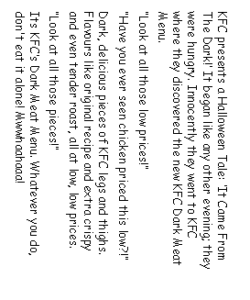

Enjoy listening to some examples from previous Year 4’s:

<https://drive.google.com/file/d/10T1qwnd-80WWQobSLEma0zqjTfNBZnsV/view?usp=sharing>

<https://drive.google.com/file/d/1j1UUAw6eQh-iDdQlGU429soS8wL1xx4X/view?usp=sharing>

<https://drive.google.com/file/d/0B89KqG-FgI1mN1N6MXpISDBtRlE/view?usp=sharing>