**Minutes of the Parent Teacher Group (PTG) EGM**

**8.00am, 23 February 2015, Room SPH201**

**Minutes prepared by Siobhan Bland, PTG Secretary**

**Present**: Matthew Mills (BPS Head of School), James Penstone (BPS Cross Campus Principal), Jason Cooper (BPS Assistant Primary Principal), Suzanne Lindley (BPS, Assistant Secondary Principal), Andrew Gordon (BPS Business Director), Genevieve Ahl (BPS Services Manager), Cheryl Rego (BPS Communications Coordinator), Malee Whitcraft (PTG Chairperson), Siobhan Bland (PTG Vice Chairperson/Secretary), Wikki Bhanubandh (PTG Treasurer), Ann Vanasin (Thai Parent Group Rep), Nog Tangtrongchitr (Assistant PTG Treasurer), Andrea Chaplin (PTG Tiger Shop Manager), Deborah Smith (PTG Newcomers Rep), Daphne Seiler (PTG Fun Day Coordinator), Catherine White (PTG Year 8 Parent Rep), Esther Lek (PTG Cross-campus Parent Rep), Amy Anuras (PTG Year 1 Parent Rep), Njah Khan (Patana parent), Jacqueline Pussegoda (Patana parent), Vani Sharma (Patana parent), Caroline Abraham (Patana parent ), Maike Shoeppner (Patana parent), Johnny Lavery (Patana parent), Alison Bastin (Patana parent), Rocelyn Kielnhofer (Patana parent), Janine Minchin (Patana parent), Alexandre Borione (Patana parent), Tony Bickford (Patana parent), Chik Ching Yip (Patana parent), Tamar Kes (Patana parent), Suzie Jhanji (Patana parent), Vivian Ploem (Patana parent)

**Meeting commenced at 8.05am**

1. **Apologies:**

* Michael Smith (Secondary Principal), Clare Sharp (Primary Principal), Helen Thew (Assistant Principal, Student Welfare), Emma Goligher (Development, Alumni and Marketing Manager), Malene Bloch Lundgaard (Primary Parent Rep), Dyan Zimmerman (PTG Secondary Parent Rep)

1. **Chairperson Welcome:**

* Malee Whitcraft welcomed everyone and thanked them for coming, summarized the PTG Review process that has taken place to date, and introduced Siobhan Bland to Chair the meeting.
* Siobhan thanked the PTG team and the Patana community for participating in the review process.
* She said that from the review that was undertaken that it was clear that the general feeling was the number one priority for the PTG was supporting the Patana community, over fundraising depending on resources. She also highlighted that Patana does have a pool of parents who are willing and able to volunteer, that there was a proportion of the Patana community that did not volunteer for the PTG, and that although this was the case it was not because they did not value the PTG.
* Siobhan also pointed out that the review also highlighted the need to recognize the student body and encourage their involvement.
* Siobhan pointed out the PTG works very closely with the school and that events like Fun Day and our new PTG Room and Tiger Shop are a testament to how much the school values its PTG.
* Siobhan summarized the changes that have already taken place as part of the review including the transfer of financial administration role from the PTG to the school, and alignment of PTG communications with the school’s media, both in order to reduce duplication. She also mentioned the proposed amendments to the PTG Constitution and that the purpose of the EGM was to endorse the PTG review Recommendations and adopt the proposed amendments to the PTG Constitution.
* Siobhan thanked the Patana community for participating in the PTG Review process and that it was especially timely given the school is in its 58th year and that the PTG Constitution was in its 21st year.

1. **Purpose of the EGM:**

* Siobhan highlighted the purpose of the EGM and highlighted that a quorum was reached for the EGM requisition deeming it valid. Refer attachment 1: PTG EGM Attendance Sheet (23 February 2015)

**4, 5 & 6. PTG Review Recommendations and PTG Constitution Amendments:**

* Siobhan highlighted the PTG Review Recommendations and summarized the proposed amendments to the PTG Constitution.
* **MOTION: That the PTG endorses the PTG Review Recommendations and adopts the proposed amendments to the PTG Constitution.**

PTG Review Recommendations: *Consistent with the adopted minutes of the PTG Review Focus Group, it is recommended that:*

1. *The PTG considers options for funding its operating budget, and makes recommendations at a PTG Meeting;*
2. *The PTG Constitution be amended and adopted at an EGM; and*
3. *The PTG aligns its activities with the PTG Constitution amendments, once endorsed.*

*Proposed amendments and adopted PTG Constitution: Refer Attachment 2 - 1 PTG Constitution (Amendments adopted at the EGM of the Patana Parent Teacher Group on 23rd February 2015)*

**The motion was supported by the majority.**

**Moved: Wikki Bhanubandh Seconded: Daphne Seiler**

* Matthew Mills thanked Siobhan Bland and the PTG for their work reviewing the PTG and documenting the process; he said that it will be useful for the school’s accreditation process. He also thanked Daphne Seiler and the Fun Day Team for another great Fun Day that was very well organised and a really fun day out for the Patana community.

1. **Any Other Business:**

* No other business was raised.

***Note:***

* *During informal discussions after the meeting, the following* ***ACTION*** *was noted: PTG to prepare a funding proposal for the PTG Committee for 2015/16 and present it to the BPS Business Department before 11 March 2015 for approval. In December 2014 the Foundation Board agreed to fund a proportion of the PTG’s operational budget, as part of the PTG Review process.*

**Meeting ended at 9.25am**

**Attachment 1: PTG EGM Attendance Sheet (23 February 2015)**

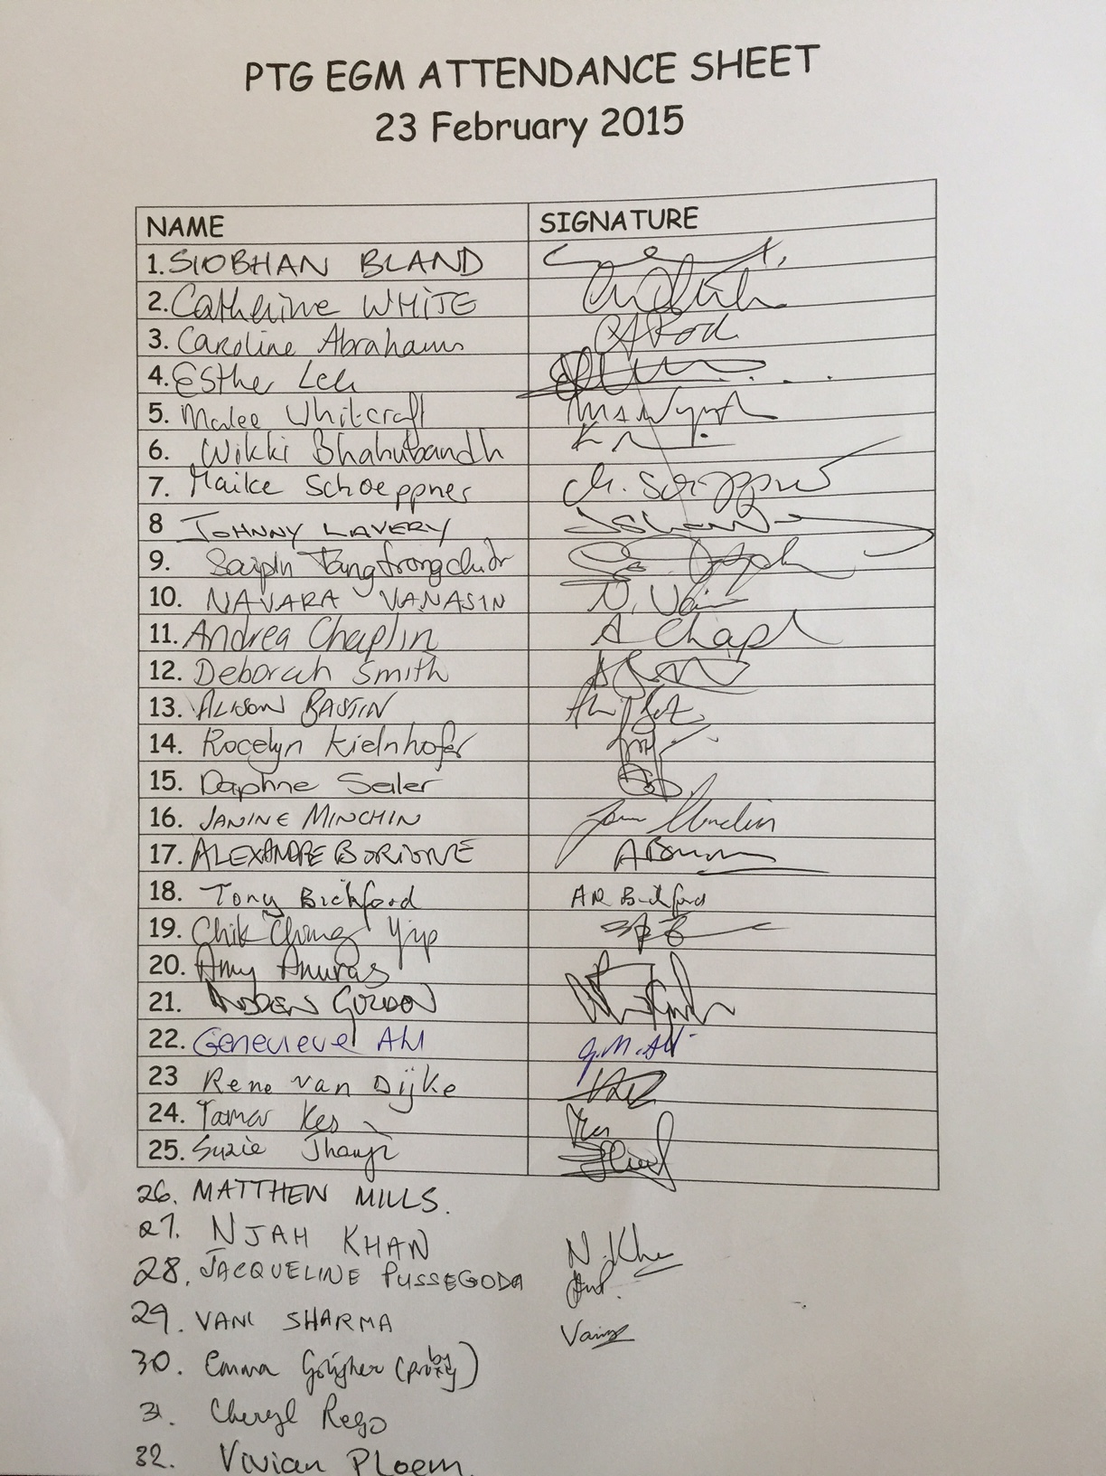

**Attachment 2:**

**PTG CONSTITUTION**

*Amendments adopted at the EGM of the Patana Parent Teacher Group*

*on 23rd February 2015, and as adopted at the AGM on*

*16th May 2014, 27th May 2011 and14th June 1994*

*Parent Teacher Group*

*Bangkok Patana School*

*Bangkok, Thailand*

**ARTICLE I – NAME**

1. The name of this organisation shall be the Parent Teacher Group of Bangkok Patana School, Bangkok, Thailand, hereinafter referred to as the “PTG”.

**ARTICLE II – OBJECTIVES**

1. The purpose of the PTG is to promote and assist the development of the school, to advance its interests, and to foster the goodwill of parents, teachers, staff, and students (the Patana Community).
2. The PTG achieves this by:
3. Strengthening relationships among the Patana Community and promoting opportunities to meet socially in a friendly environment;
4. Encouraging the involvement of parents of all nationalities in school activities;
5. Facilitating the flow of information between parents and the school;
6. Supporting a caring, community minded student body by promoting active participation and decision making within school life; and
7. Assisting the school by any means that the Head of School and/or Foundation Board consider helpful and appropriate.

**ARTICLE III – MEMBERSHIP**

1. PTG membership shall automatically be held by:
2. Any Parent or Guardian with a child/children attending Bangkok Patana School; and
3. Any Staff member.

**ARTICLE IV – THE PTG COMMITTEE**

1. The PTG Committee shall consist of ten (10) voting parents and five (5) voting members of the School’s Senior Leadership Team (SLT), including the Head of School, Cross-Campus Principal, the Principals of the Primary and Secondary Schools, and the Business Director (or their designated representatives).
2. The parent members of the PTG Committee shall hold the following offices:
3. Chairperson;
4. Vice Chairperson;
5. Secretary;
6. Treasurer;
7. Thai Affairs Liaison (appointed by a representative of the Thai Parent Group);
8. Communications Coordinator;
9. Tiger Shop Manager;
10. Cross-Campus Parent Representative;
11. Primary School Parent Representative; and
12. Secondary School Parent Representative.
13. The parent representatives shall be elected by a majority vote of members (or their proxies) present at the Annual General Meeting (AGM). If a position is or becomes vacant after the AGM it may be filled by a majority vote of the remaining PTG Committee, even if it does not constitute a PTG Committee quorum. If the PTG Committee Chairperson, and/or two (2) or more of the Executive Committee resigns before the subsequent AGM, a decision is required by the Head of School as to whether or not to dissolve the PTG Committee. In the event that a PTG Committee is dissolved, the five (5) voting members of the School’s SLT shall appoint an interim PTG Committee to oversee the appointment of a new PTG Committee to be elected at an EGM consistent with Article VII.
14. The term of each PTG Committee member in one position should be two (2) years, with the maximum number of consecutive terms served by each PTG Committee member in one position being two (2).
15. There shall be a minimum of six (6) PTG Committee Meetings each school year. The attendance of at least seven (7) PTG Committee members shall constitute a quorum at a PTG Committee Meeting. A quorum of PTG Committee members must be present to vote on any resolution coming before the PTG Committee. If a quorum is not present, a second meeting will be held after due notice of one (1) week has been given to all PTG Committee members, and at the second meeting at least five (5) PTG Committee members will constitute a quorum.
16. PTG Committee Meetings shall be open to all members to attend with prior notice, but only PTG Committee members have the right to vote.
17. The minutes of meetings of the PTG Committee shall be circulated to all members of the PTG Committee and a copy provided to the Director of the Foundation Board Office. The minutes will be openly available to all members of the PTG.
18. PTG Sub-committees may be formed as required, and approved by the PTG Committee. Sub-committees are to be coordinated by a member of the PTG Committee or a Sub-Committee Representative including, but not limited to the Fun Day Coordinator, International Day Coordinator and Activities Coordinator.
19. The Executive Committee shall consist of the Chairperson, Vice Chairperson, Secretary, Treasurer and Thai Affairs Liaison, unless the composition of the Executive is changed by a majority vote of the PTG Committee.
20. Before the end of its term, the PTG Committee shall commence preparations for the AGM by inviting its members to nominate for the new PTG Committee. At least seven (7) days before the AGM, a notice of the nominations received shall be sent by email to all members of the PTG. However, any member shall be eligible to stand for election at the AGM.

**ARTICLE V – REPSONSIBILITIES OF THE EXECUTIVE COMMITTEE**

1. The Executive Committee (the “Executive”) shall represent the PTG in all matters concerning the overall policies and goals of the PTG. However, the full PTG Committee must approve such policies and goals by a majority vote. The relative duties and responsibilities of the Executive and the Full PTG Committee may be determined by guidelines approved by a majority vote of the Full PTG Committee.
2. The Secretary shall be responsible for preparing the minutes of all meetings of the Executive and the PTG Committee as well as the AGMs and any Extraordinary General Meeting (EGM) of the PTG.
3. Legal Documents shall require the signatures of two (2) members of the Executive, one (1) of which shall be the Chairperson or Vice Chairperson.
4. Purchase requests shall require the signatures of between two (2) and four (4) members of the Executive for approval. Eligible signatories to purchase requests are either the Chairperson or Vice Chairperson in conjunction with the Treasurer or Assistant Treasurer. Once purchase requests are approved, the signing of cheques is subject to the school’s required signing authority.
5. The Treasurer shall be responsible for coordinating the administration of the funds of the PTG with the School, and shall prepare a statement of accounts in consultation with the Financial Controller of the School, which shall be presented and approved at the AGM of the PTG.

**ARTICLE VI – THE ANNUAL GENERAL MEETING**

1. There shall be an Annual General Meeting (AGM) of the PTG held in May each year.
2. All members of the PTG shall be advised of the date and place of the meeting at least two (2) weeks in advance. Notice of the AGM shall be accompanied by the agenda for the meeting and the proxy forms.
3. The annual statement of accounts shall be prepared by the Treasurer, made available to members of the PTG Committee at least seven (7) days prior to the AGM, and presented at the AGM.
4. The financial year of the PTG shall coincide with the term of the elected PTG Committee until the end of April (so that statements can be prepared in time for the AGM), and budget items are not committed beyond the term of the elected PTG Committee.
5. A maximum of two (2) proxies can be carried per PTG Committee member.
6. The AGM shall require a quorum of 25 members (including proxies) and all resolutions shall be decided by a two-thirds majority vote.
7. Without the required quorum no resolution is valid and the PTG Committee shall call a second AGM within one (1) month. At this meeting a quorum shall be 25 members.
8. The last item on the agenda of the AGM shall be the election of the new PTG Committee, with nominations having been sought prior and sent to all members of the PTG at least seven (7) days before the AGM. The official handover to the new PTG Committee shall take effect from the time of the election.
9. If no PTG Committee is elected at the AGM (or if a PTG Committee dissolves for any reason during its term), the School’s Financial Controller may sign cheques to pay for items already approved by the previous PTG Committee, but for no other purpose. The Financial Controller shall release their responsibility for coordinating the administration of all such PTG funds to the new PTG Committee once it is formed.

**ARTICLE VII – EXTRAORDINARY GENERAL MEETING**

1. The PTG Committee shall, on the requisition of not less than 25 members, convene an Extraordinary General Meeting (EGM) of the PTG within two (2) months of the receipt of the requisition.
2. A requisition of members for an EGM shall:
   1. State the purpose of the meeting;
   2. Be signed by the members making the requisition; and
   3. Be lodged with the Chairperson or Secretary.
3. A quorum of an EGM shall comprise 25 members (or their proxies).

**ARTICLE VIII – AMENDMENTS TO THE CONSTITUTION**

1. Amendments to the Constitution can only be made as a result of resolutions passed at an AGM as per Article VI, or an EGM as per Article VII.
2. Proposals for amendments to the Constitution must be submitted to the Executive in writing at least two (2) weeks in advance of the AGM or EGM and such proposals received will be tabled for discussion and resolution at the AGM as per Article VI, or an EGM as per Article VII.

**ARTICLE IX - DISSOLUTION**

1. The PTG may be dissolved by a resolution presented at an AGM, or EGM, where this is included in the notice of the meeting. The resolution must have the agreement of two thirds of those voting (or their proxies) and must give instructions for the disposal of any assets remaining after paying outstanding debts and liabilities. A quorum of an AGM, or EGM, shall comprise 25 members (or their proxies).
2. The net assets will be given to the school with not less than 25% given to an agreed charity for an educational purpose.