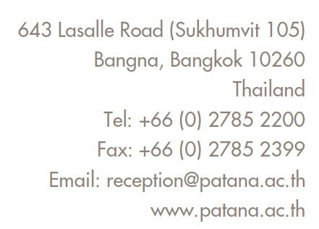

**Bangkok Patana KS2 Digital Code of Conduct**

**Password Safety**

I will not share my passwords with anyone except my teacher and my parent/s.

I will not use other students’ computers or log in using their personal information.

**Online Digital Safety**

I will ask permission from a trusted adult before I go on the internet.

I will not talk to, or message with, strangers online.

I will not share personal information when online.

I will check with my parents or teacher before downloading/installing any software or apps.

I will tell a trusted adult if I am worried or upset about anything I see on the internet.

I understand that what I see and read on the internet may not be true.

**Email and Messaging**

I will be polite when sending messages and emails or when posting comments online.

I will not click on links from people I do not know.

I will not send SPAM or chain emails.

If I get a rude or upsetting message I will tell my teacher or my parents.

I understand that if I send rude or upsetting emails, they will be detected by my teachers.

**Agreeing Digital Rules at Home**

I will talk with my parent/s to agree rules and time limits for internet use and screen time.

I will share my favourite online sites, games and apps with my family.

Once in Y6**,** I will shut down my laptop each evening and bring it into school fully charged.

I will take care of my devices; I will not eat or drink near to my laptop.

**Student Declaration**

My aim is to create a Positive Digital Footprint.

I understand that if I do not follow this Digital Code of Conduct, my parents will be contacted, my computer use may be limited and my school email account blocked.

**Student Name: ………………………………………….. Date: …………………….**

**Student Signature:………………………………………**

**Parental Agreement**

I will model responsible and safe computer/device use.

I will talk with my child to agree rules and time limits for internet use and other screen time.

I will help my child to develop a Positive Digital Footprint.

**Parent Name: ……………………………………………… Date: ……………………..**

**Parent Signature: …………………………………………**