**How to make a quiz in Scratch**

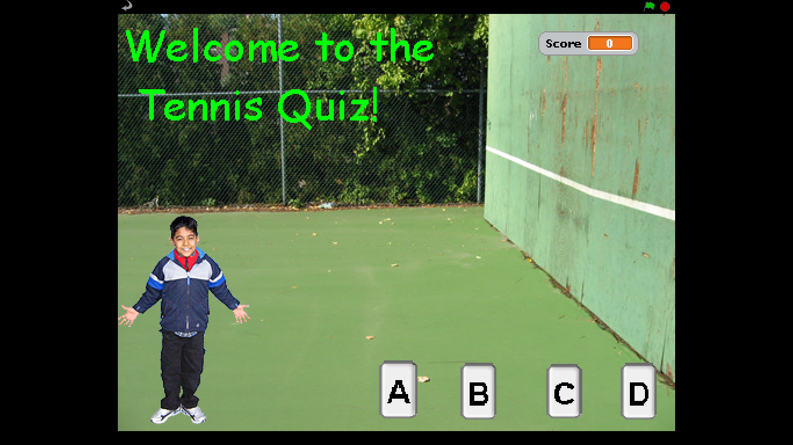

The quiz can be about any topic, this one is about tennis. There are 6 sprites; the boy who gives instructions and the quiz questions/answers; button A; button B; button C; button D; the Welcome title.

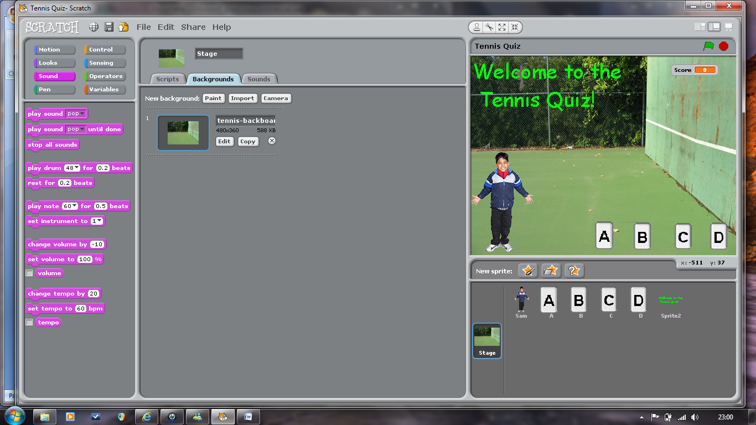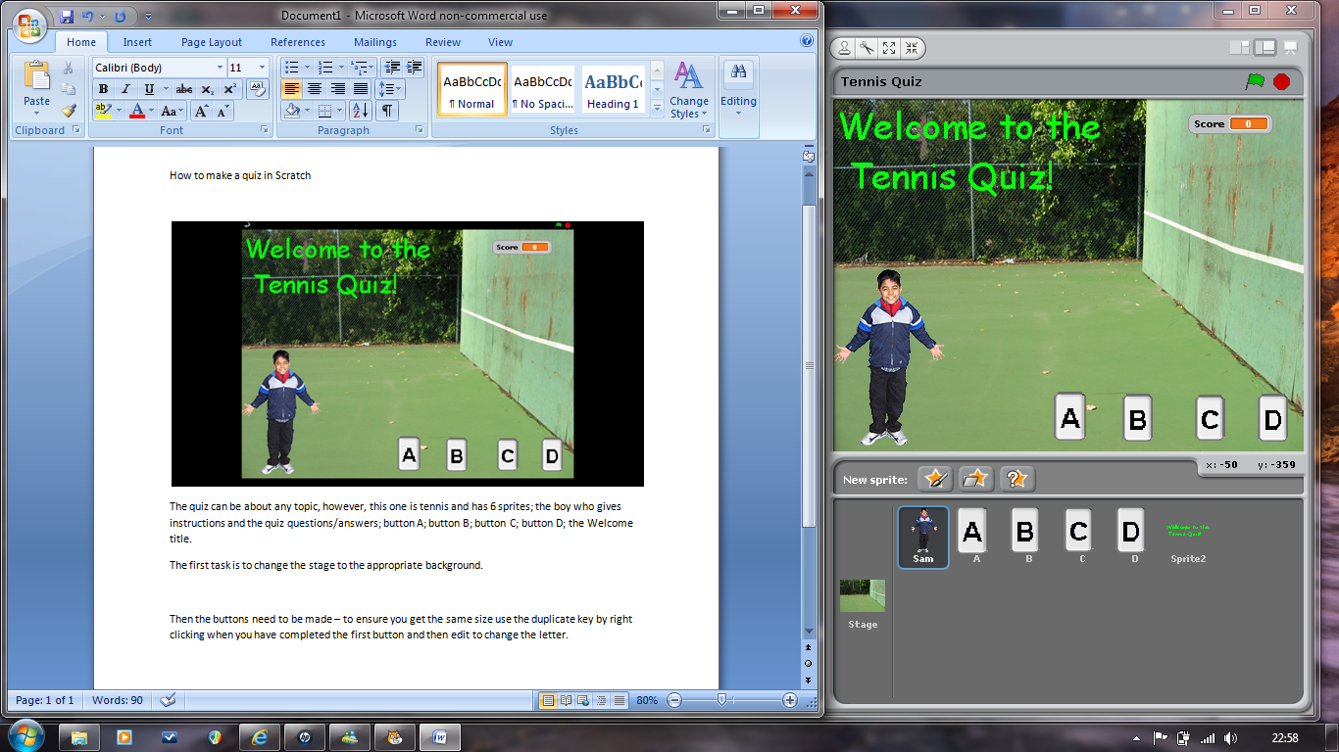

The first task is to change the stage to the appropriate background.

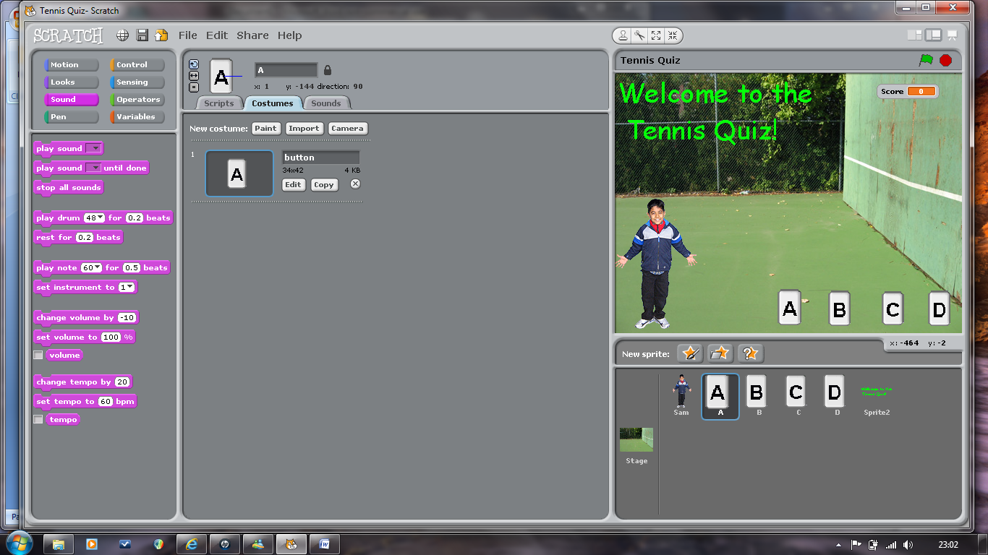The buttons now need to be made – you can either make your own via ‘paint new sprite’ and then put the letter on using the text tool or you can import the buttons by ‘paint new sprite’ then choose ‘import’ ‘things’. You can then change the size and add letters using the text tool. To ensure you get the same size buttons use the duplicate key by right clicking when you have completed the first button and then edit to change the letter.

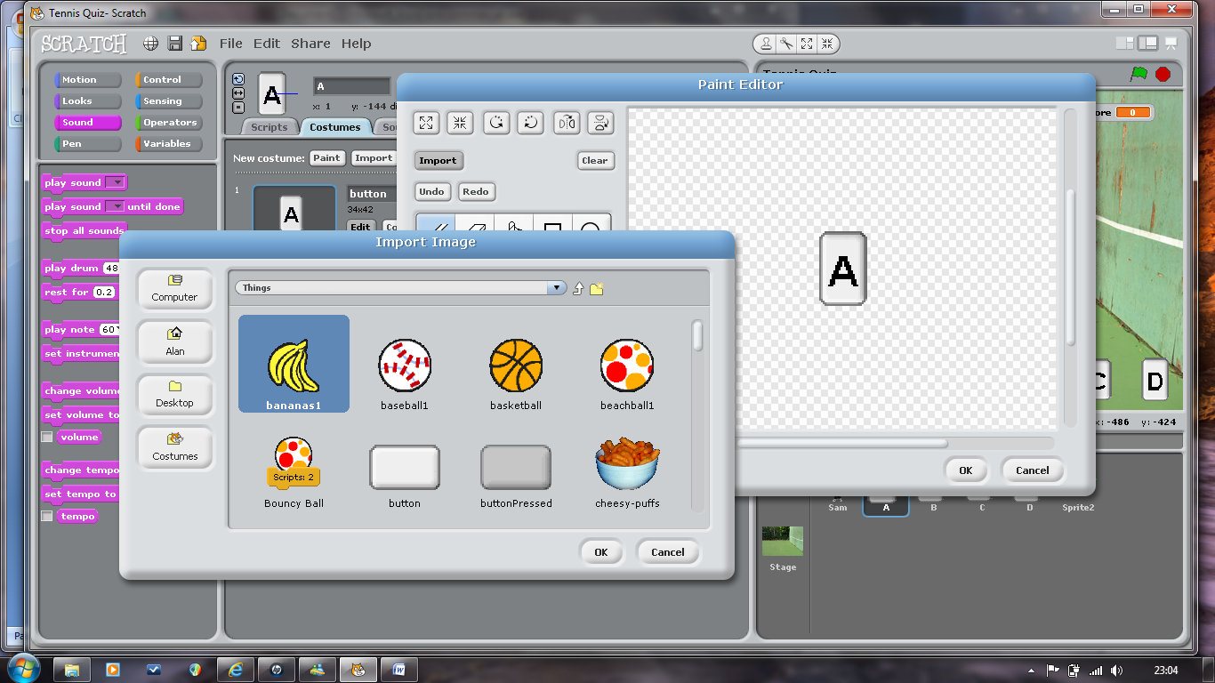

To create the title for the quiz you need to paint a new sprite by clicking paint new sprite. Using the text tool choose your font style and size.

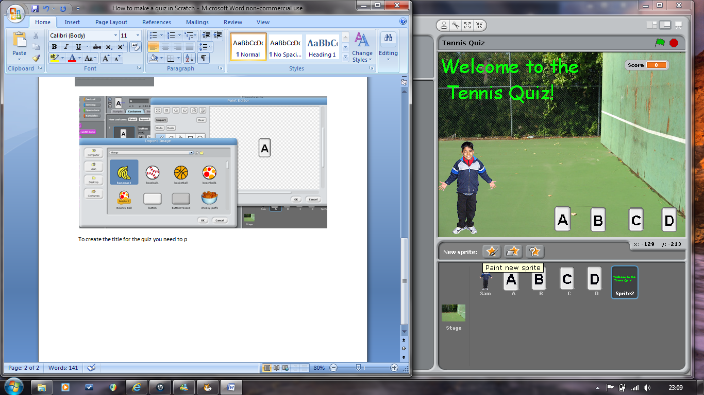

NOTE: Once you have created your sprites don’t forget to rename them – this will ensure you won’t get confused.

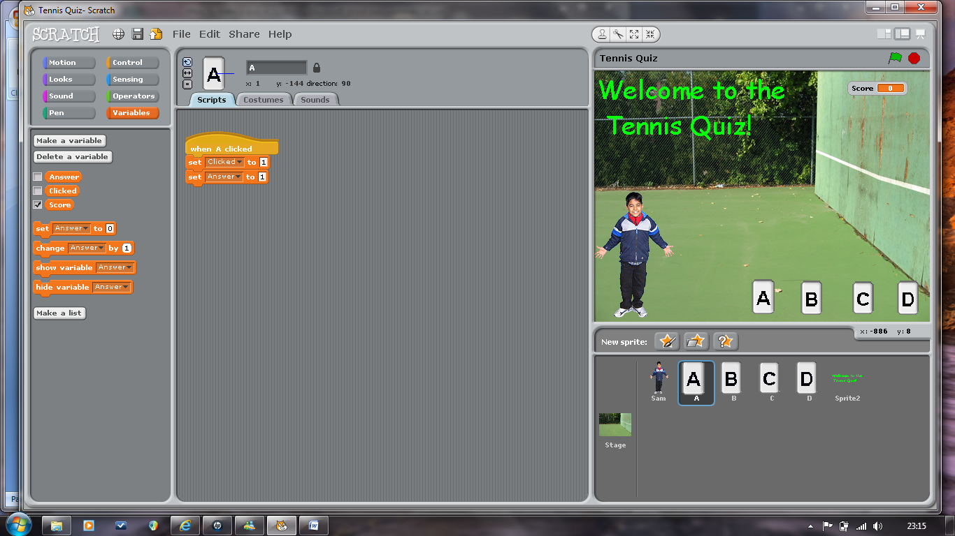Now you have all the sprites required to make the quiz, you need to programme them.

The first task is to make your variables. You will need three global variables: Clicked; Answer; Score.

Each button sprite will require a control and two variables.

When the button is clicked, you want the variable to register this click – hence ‘set CLICKED to 1’ (remember it is 1 because you click the mouse key once!) Each button needs this code as it will be clicked. You then need your variable to recognise and check the answer is correct, therefore, each button needs to be given a number; eg, A=1, B=2, C=3, D=4. You then need to use the ‘set ANSWER to ......’ variable shown below.



Don’t forget:

Button A is going to be Answer 1

Button B is going to be Answer 2

Button C is going to be Answer 3

Button D is going to be Answer 4

Each button needs a control and a set variable clicked to 1 and a set variable answer related to the above letter and number.

The rest of the programming is put onto the boy, Sam.

There are 3 main parts of programming for the quiz:

1. The introduction to the quiz.
2. The question and answer check.
3. The end of the quiz.

The question and answer check is the same for each question, therefore, this part of the code can be duplicated for each question.

**To introduce the quiz:**

Make sure you are on the correct sprite, in this case ‘Sam’.

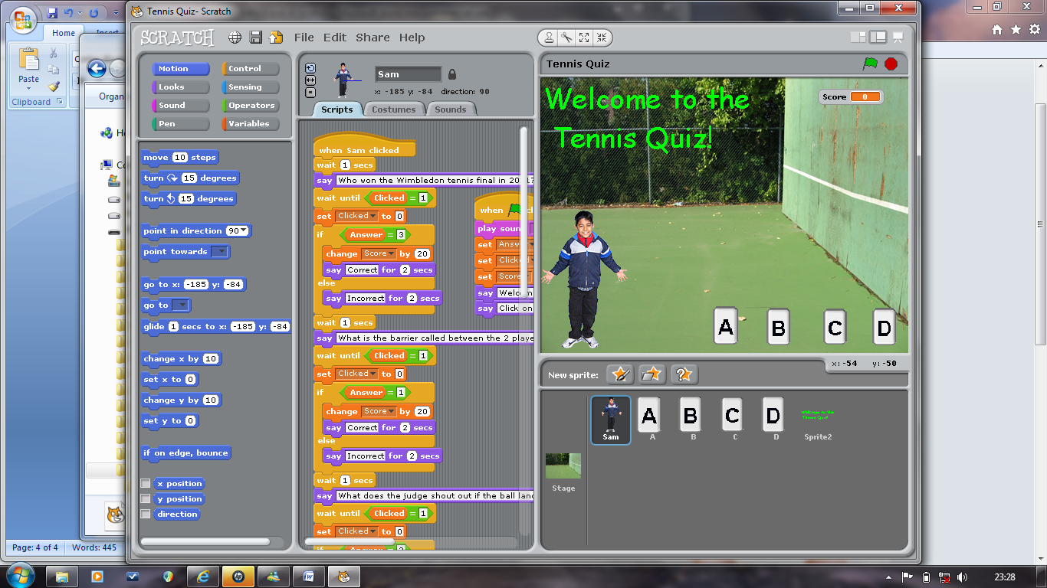

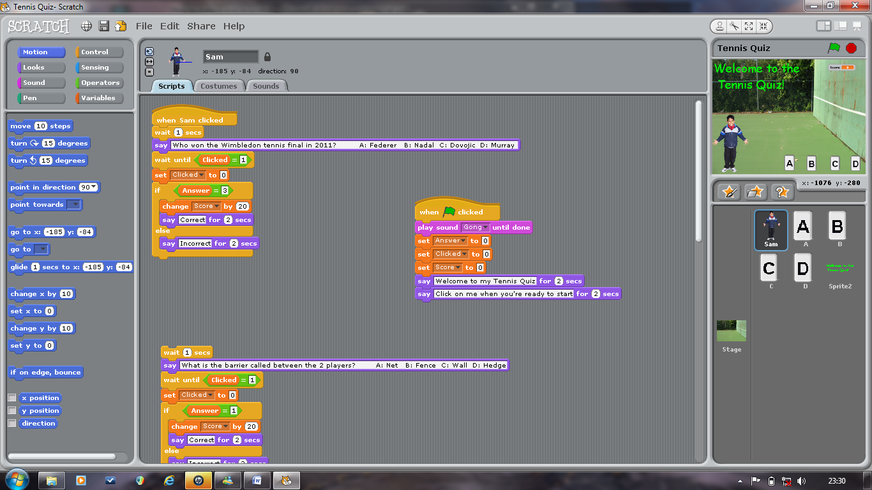When the ‘green flag’ is clicked you want the quiz to start. You can play a sound or try recording a welcome to your quiz on the SOUND actions.

You will need all three global variables to be set to 0 each time the game is started. Then choose an introduction and tell the user what to do next, eg, ‘Click on me when you are ready to start’.

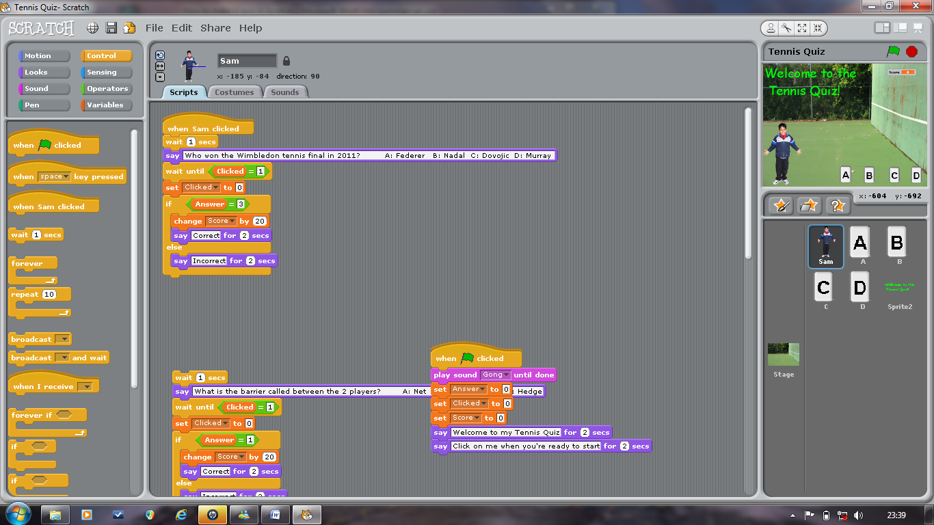

You need to start the process by using the Control ‘When ....... Clicked’.

The rest of the code is repeatable for each question, apart from:

1. You need to change the question!
2. You need to relate the IF Answer= ...... to the right answer.

Remember each button was programmed so that ‘Set CLICKED to 1’ – now you need to wait until ‘CLICKED=1’ this tells the programme to wait until a button is clicked. After a button is clicked it then needs to be reset to ‘0’ so that the programme wait for a button to be clicked again.

You then need an ‘IF ..... ELSE loop’. IF a certain condition is met, for example, the answer is correct, THEN you want the score to increase and respond to the user that they answer is correct. IF the answer is not correct then you need to fill in ELSE to state what you want to happen if the answer is wrong, for example, ‘Say Incorrect for 2 seconds’.

You will notice that the correct answer to this question is ‘C: Djokovic’ – this is where you will need to remember what number you gave each button. As we gave ‘C to =3’ you need to enter the number 3 in the IF ANSWER = ........ This will tell the programme that this is the correct answer and will change the score and then say correct.

THIS CAN THEN BE REPEATED FOR EACH QUESTION, JUST MAKE SURE YOU CHANGE THE QUESTION & ANSWERS and ENTER THE RIGHT ANSWER NUMBER IN THE ‘ IF ANSWER = ....... ‘ BOX.

When you have finished entering all your questions you need to finish the quiz. To do this we use:

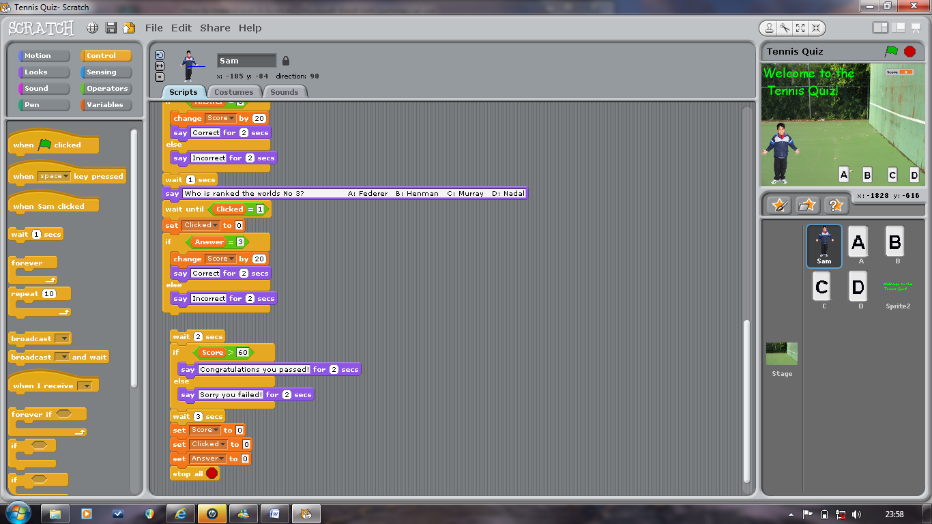

You then need to insert another IF ....... ELSE loop. This will check to see if the score is greater than 60, and if it is ‘Sam’ will say ‘Congratulations you passed!’, and if the score is not greater than 60 then ‘Sam’ will say ‘Sorry you failed!’.

You then add in a wait and reset the three global variables to 0.

You have now created a Quiz in Scratch, have fun creating another or adapting this one!