643 Lasalle Road (Sukhumvit 105)

Bangna, Bangkok 10260

Thailand

Tel: +66 (0) 2785 2200

Fax: +66 (0) 2785 2399

Email: [reception@patana.ac.th](mailto:reception@patana.ac.th)

www.patana.ac.th



**24/8/2015**

**To: Parents/Guardians of Year 7 Students**

**Dear Parents/Guardians,**

It was a great pleasure to finally meet Year 7 on the first day of school and I’d now like to extend the welcome to all of you too. The Year 7s appeared to hit the ground running on Wednesday (quite literally during the Treasure Hunt) and have met their first full week at Secondary School with enthusiasm, zest and good humour. This is my 9th year at BPS and I am sincerely looking forward to working with both students and parents as Head of Year 7.

It would be wonderful to meet as many of you as possible at the Informal Coffee Morning for Year 7 and New Secondary Parents on Thursday the 27th August, from 8am in the Theatre. There will also be a Year 7 Coffee Morning on Thursday 10th September. You are welcome to attend both coffee mornings.

The year ahead is an extremely important one in terms of developing productive behaviour and settling down socially; the Year 7 tutor team and I are dedicated to ensuring your children have the opportunity to achieve their potential, socially and academically, throughout the year.

***Staff and Communication***

 The Year 7 Tutor Team this year (with staff codes) is as follows:

|  |  |  |  |
| --- | --- | --- | --- |
| Tutor Group/House | Tutor Base | Tutor | Staff Code |
| 7C (Phuket) | Sec211 | Mun Yee Chong | MUCH |
| 7D (Samui) | Hum207 | Alan Darby | ALDR |
| 7E (Lanta) | Sec209 | Dr. Miles Ellerby | MIEL |
| 7K (Chang) | Sec304 | Karen McGuire | KAMG |
| 7L (Samui) | Hum312 | Tania Leyland | TALE |
| 7M (Lanta) | Sec201 | Dr. Louise MacGregor | LOMA |
| 7S (Phuket) | Hum310 | Simon Worrall | SIWR |
| 7W (Chang) | Hum111 | Mark Willis | MAWI |

Your child’s tutor will be the teacher that your children will have the most frequent contact with and should be your first point of contact with the school should any pastoral issues arise. In the case of academic concerns, however, the first point of contact should be your child’s subject teacher.  You are more than welcome to copy me into any such communications.

Occasionally, you may feel it is necessary to meet with your child's tutor or subject teacher.  We welcome the chance for face-to-face contact, but please do make an appointment first and give some indication of the nature of your concerns.

It is essential that we are able to maintain an accurate record of all students on campus. Please let your child’s tutor know the nature and likely duration of any absence (either by email to the tutor or by phone to the Secondary office) before 7.40am. If you are aware in advance of your child’s absence, for example due to an appointment or trip that needs to be taken during school time, please email the tutor with the dates so that this can be noted on the register and subject teachers can be informed.

Please do check and update your own personal contact details and the medical details of your child as necessary. This is **vital** as it is our primary source of information and ensures that we can contact you in case of an emergency.

Another valuable point of contact is through the PTG representatives for Year 7. We have Tess Liptiwat and Saipin (Nog) Tangtronchitr working with us this year. There is an opportunity to meet them at our coffee mornings and you may also contact them on the email addresses below.

**Tess Liptiwat** [tessliptavat@hotmail.com](mailto:tessliptavat@hotmail.com)

**Saipin (Nog) Tangtronchitr** [saipin@i8d.co](mailto:saipin@i8d.co)

***ICT***

All Secondary students need to have a laptop at school each day.  All student laptops must be registered at the ICT Office so that they will operate as needed at school.  If there are any issues with this, please contact your child’s tutor or email me directly.

***Home Learning***

Continuing the learning process outside of the school environment is an essential component in your child's learning at Bangkok Patana School. Home Learning can be quite a challenge at the beginning of the year.  For this reason, the Year 7 students will be gently eased into the Home Learning programme from Week 3.  Subject teachers will set Home Learning on a regular basis and in a variety of forms.

During Term 1, Year 7 students should have no more than approximately one hour of Home Learning each night. All tasks should be completed carefully and on time. If students do not understand an assignment we encourage them to ask for help from their teacher rather than to submit incomplete work. The Home Learning timetable is below and can also be found on Firefly via this link:

<http://community.patana.ac.th/curriculum-1/ks3/ks3-home-learning-timetable>

Thank you in advance for your support in encouraging your child to plan his or her time to effectively complete home learning.

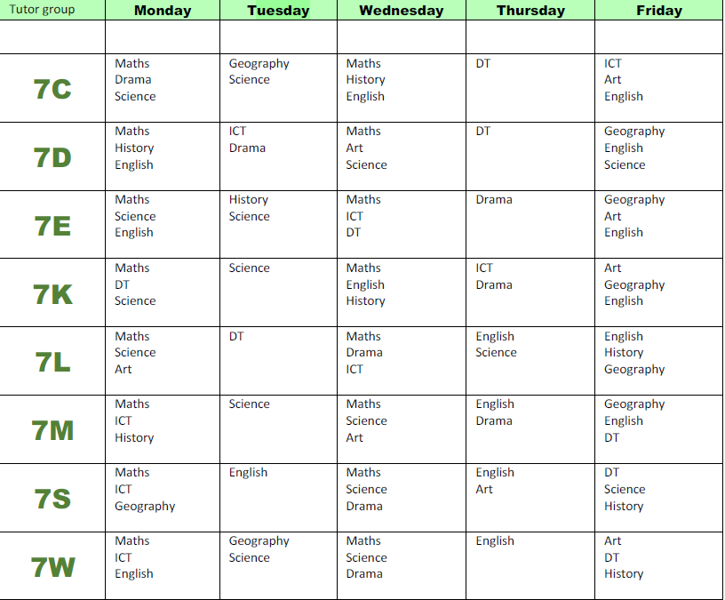

***Systems for monitoring student behaviour***

*Home Learning* – Failure to complete home learning tasks will initially be dealt with by the subject teacher. Parents will be copied into an e-mail about the home learning to the student; the aim here is to encourage a three-way communication process, culminating in the home learning being completed and associated problems being remedied.

*Conduct Detention* - Student behaviour is generally excellent at BPS, but occasionally problems arise. Conduct detentions help students to understand the effect of inappropriate behaviour. If the case arises for a student to be detained after school (which is rare), then parents will be notified in advance.

*Uniform* - The guidelines are detailed online in the Student Handbook for KS3, and your support in ensuring that your child leaves for school dressed appropriately is greatly appreciated, especially with reference to skirt length, footwear, jewellery and make-up. We would also ask for your help in monitoring what students are wearing for non-uniform days.

***Transport***

Bus Rules and information regarding transport are sent to parents along with the bus routing. Please read through these documents carefully to ensure that you are aware of the established rules and procedures.

If arrangements do need to be urgently altered on any given day, students may not do this themselves; parents must call the Transport Office **before 11am**. After this time it will be too late. The phone number for the Transport Department is 02 785 2470. The office is staffed from 6.00am - 6.00pm Monday to Friday.

Transport can also be contacted by emailing [transport@patana.ac.th](mailto:transport@patana.ac.th)

***Extra-Curricular Activities***

The Extra-Curricular Activities programme, which can be accessed online, is extensive and offers many exciting opportunities. We encourage students to participate as an excellent way to explore interests, learn new skills, have some fun and expand their social circles. If you have any queries regarding Extra-Curricular Activities, please contact Miss Hannah Marshall ([hama@patana.ac.th](mailto:hama@patana.ac.th)).

***Tutorial Programme:***

At Bangkok Patana School we have a very supportive Year 7 Tutorial Programme. This year we begin by reinforcing appropriate social expectations and value systems and ensuring that the Year 7s settle in to Secondary School.  The over-arching theme of Tutorial during Term 1 is ‘Overcoming Challenges’. Highlights this term will include Internet safety awareness, caring for and including people in friendship groups and guarding against bullying, as well as preparing for our Residential Visit.

The issue of Internet safety is an extremely important one for children. We strongly encourage parents to monitor your child’s internet access and social media presence. This is a topic that I will touch on again throughout the year and at the Coffee Mornings. Please do contact me should you have any concerns or queries related to this issue.

***Support Tutors and Tutor Mentoring – new in 2014/15***

Each tutor group is assigned one support tutor. The support tutors will take registration one morning per week to allow the tutor to have dedicated 1:1 mentoring time with students in the tutor group. The purpose of these meetings is to ensure our students are able to fulfil their potential. This is an invaluable source of support for your child this year.

***Important Dates for This Term***

As always, there is a lot happening at Patana this term. Here are some of the key dates:

Monday 17th August – ECA Block 1 sign up goes live

Monday 24th  August – Season 1 Sport try outs commence

Thursday 27th  August – Secondary New Parents’ Coffee Morning in the Conference Centre

Monday 31st August  – ECA Block 1  begins

Monday 7th September – Y7 MidYIS testing

Thursday 10th September – Y7 Parents’ Coffee Morning

Wednesday 16th September – University Information Evening

Friday 18th September – School Holiday

Monday 21st September - ECA Block 2 sign up goes live

Sunday 27th September - Patana Fun Run @ Ancient City

Thursday 1st October – Freedom from Chemical Dependency Meeting for Parents (6 – 7.30pm)

Friday 2nd October – Tiger Spirit Day

Friday 2nd October – Key Stage 3 Secondary Dance

Monday 5th October – Y7 Student and Parents’ Conference

Friday 9th October – Key Stage 3 Strings Festival @ BPS

Friday 16th October – School closed for students (Teacher Training)

Monday 19th October – Half-Term Holiday

Friday 30th October – ECA Block 1 ends

Friday 30th October – SILC Bazaar @ BPS

Friday 6th November – Patana Plugged (6 – 8pm)

Monday 9th November – ECA Block 2 begins

Tuesday 10th November – International Day

Monday 16th November – Y7- Y10 & Y12 Secondary Residential Visits

Saturday 28th November – Ploenchit Fair @ BPS

Wednesday 2nd December – House Athletics

Monday 7th  December – Day off in honour of his HM King’s Birthday

Thursday 10th  December – Day off for Constitution Day

Wednesday 16th December – Christmas Concert (6 - 9.30pm)

Friday 18th December - Christmas Assembly and the end of Term

Please do check the calendar for confirmation.

I hope to see many of you over the coming term and I am looking forward to sharing a successful year ahead.

Yours faithfully,

Mr Owen McDevitt

Head of Year 7

[owmc@patana.ac.th](mailto:owmc@patana.ac.th)

Tel: +66 (0) 2785 2200 (ext: 2340)