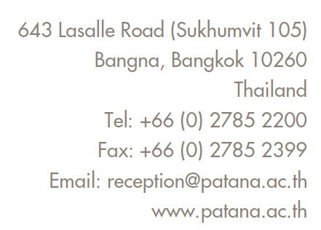

**Bangkok Patana Foundation Stage/KS1 Digital Code of Conduct**

|  |  |
| --- | --- |
| I will always ask my parents or teacher  before I use a computer, tablet or phone. |  |
| I will tell my parents or teacher if I see something that worries or upsets me. |  |
| I will not eat or drink when close to  a computer, tablet or phone. |  |
| I will take care of any computers, tablets  and phones that I am allowed to use. |  |
| I will try to play in many different ways every day. |  |

**Parent’s Agreement:**

I will supervise my child's use of electronic and online devices.

I will make sure that websites, apps and games are age appropriate.

I will help my child learn to balance their time between online and other types of play.

We agree to this Digital Code of Conduct.

Student Name: _______________ Student Signature: _____________

Parent Name: ________________ Parent Signature: _______________

Date: ______________