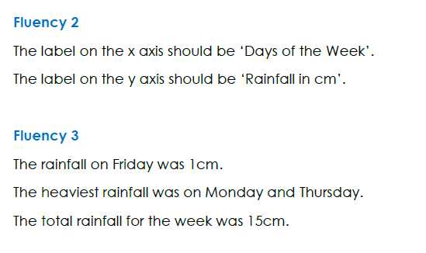1.

2. Line graph because its trying to show the temperature over a period of time.

3. Pets🡪bar, height of sunflower🡪line, temperature🡪bar, Children clubs🡪bar

Reasons may vary

4. 