Recommended Podcasts, Twitter Feeds and Facebook Groups for Coaches

Please share your own recommendations

Podcasts
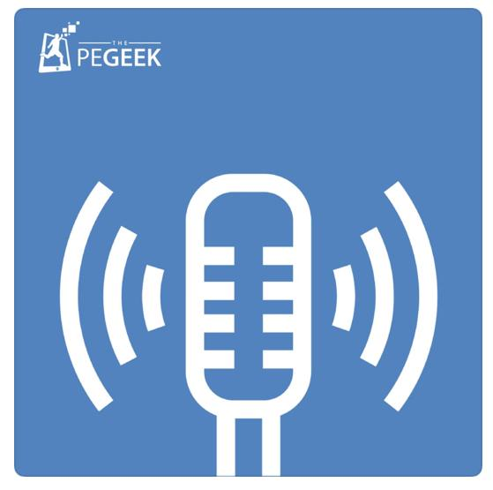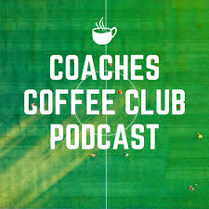

Twitter Feeds
#thisisPE

Facebook Groups/Pages to Follow
Swim Coaches Ideas Exchange Group
Globetrottin AD’s
International PE Teachers and PE Friends
Changing the Game Project
International Association of Athletic Directors and Coaches (IAAAC)

