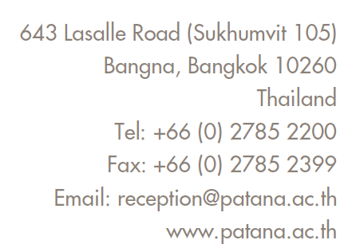


KS2 Digital Code of Conduct

Please keep at home for reference

Password Safety
I will never share my passwords with anyone except a trusted adult.
I will never ask someone to share a password with me.
I will not use somebody’s device without first asking permission.

Online digital safety
I will keep my personal information private.
I will ask permission from a trusted adult before I go online.
I will not communicate with strangers online.
I will not click on links from people I do not know.
If I see something that worries me, I will tell a trusted adult.

Good digital manners
I will be polite when communicating online.
I will not send SPAM or chain emails.
If I send rude or upsetting emails, there will be a consequence.

Agreeing rules and time limits at home
I will talk with my parent/s to agree rules and time limits for internet use and screen time.
I will check with my parents before downloading/installing any software or apps.
I will share my favourite online sites, games and apps with my family.
I will take good care of all devices; I will take care not eat or drink near to my laptop.
If I am in Y6, I will shut down my laptop each evening and bring it into school fully charged.

Student Agreement  - I agree to this Digital Code of Conduct.  - I know that if I do not follow this Digital Code of Conduct, school may contact my parents, limit my computer use and block my school email account.  Student Signature:  Date: | Parent Agreement  - I will model responsible Digital Citizenship.  - I will talk with my child to agree rules and time limits for internet use and other screen time.  Parent Signature:  Date:

