Search the Internet to find out the answer to each question, insert an image to illustrate your answer and note down the web address where you found your answer.

1. How tall is Blackpool Tower? EXAMPLE
Answer:  518 ft 9 ins tall | Image:  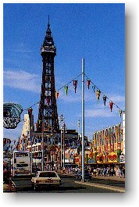 | Web Address:  http://www.tourist-information-uk.com/blackpool-tower-pleasure-beach.htm

2. Which is the longest river in the world?
Answer: | Image: | Web Address:

3.Who painted the Mona Lisa?
Answer: | Image: | Web Address:

4. Who wrote the book Charlie and the Chocolate factory?
Answer: | Image: | Web Address:

5. Where is Ayers Rock?
Answer: | Image: | Web Address:

6. How many miles high is Mount Everest?
Answer: | Image: | Web Address:

7. How long did Queen Victoria reign for?
Answer: | Image: | Web Address:

8. Which country features a maple leaf on its flag?
Answer: | Image: | Web Address:

