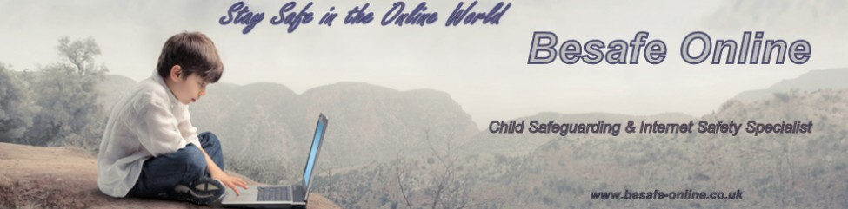

Jonathan Taylor MSc
Besafe Online
9, Locksley Gardens,
Winnersh,
Berkshire,
RG41 5NZ
07877943082
May 2014

Dear Members
E-Safety for Independent Schools, Colleges & Academies

I am an Independent Internet Safety Consultant and provide E-Safety Awareness training to Schools & Academies, from Primary School to Secondary Schools, including Special Education Needs Schools. Most of my work and contact is with International & Independent Schools and as a result I have recently carried out training for HMC Professional Development. I am also the E-Safety consultant for COBIS (Council of British International Schools), and the Schools E-Safety consultant for Kidscape Childrens Charity.

Keeping Pace with Social media and E-Safety

Child Exploitation to Online Reputation

(Vulnerability - Risk Taker - Resilient)

The dangers of the Internet must be known, recognised, and understood to allow social workers, parents, carers and educators the knowledge, experience and patience to identify and deal with any incident of online child exploitation, inappropriate online behaviour or cyberbullying.
Facebook tops the list of sites that children sign up to under-age, with 52% of 8 to 16-year-olds admitting they had ignored the official age limit. Other popular sites include WhatsApp, used by 40% of 8 to 16-year-olds, BBM (24%), SnapChat (11%) and Ask.fm (8%).
Research has found that although 59% of children are social networking by 10 years old, just 32% of parents feel "very confident" about helping them stay safe online.
Furthermore 21% of children had posted negative comments, starting from an average age of 11, and 26% had "hijacked" another person's account and posted without permission. Some 43% had messaged strangers, starting from an average age of 12. Research suggests that children are most likely to post an image or video of themselves online or set up a fake profile for the first time at the age of 11, try Twitter and message a stranger at 12 and try services like SnapChat and Ask.fm at the age of 13. Children are gaining access to social media sites at a younger age, which could expose them to content, people or situations that are out of their depth and which they're not emotionally prepared for
Parents / Carers can no longer protect children by simply trying to limit their online experiences. Instead parents/carers need to maintain an open dialogue and encourage children to share both good and bad online experiences, talk openly and straightforwardly about the risks they may encounter online without scaring them and make sure they keep up with the latest social media crazes and work with their children rather than trying to control them.
The use of technology is quickly becoming the primary means of bullying and harassment, particularly among adolescents. Text and picture messaging through mobile phones and social media via the Internet have taken the place of the traditional schoolyard bully and have led to an explosion in bullying, harassment and other exploitive behaviours on-line. Sexting, Sexcasting, Cyberbullying, Trolling, are becoming more common through the use of social media and the expanding use of Apps on Iphones, Blackberrys and Android phones. The creation of 'Digital natives', with the realisation that now 'the younger the child, the more access to internet enabled devices is inevitable. Apps and Tablets have become the game changer allowing for online usage to become inter-generational, which if not known could result in inappropriate Content being viewed - Inappropriate Conduct occurring or Inappropriate Contact being made

The following are of some of the Schools that have recently received E-Safety training;
Epsom College, Surrey Dwight School, London Aldro School, Surrey
City of London Freemans, Surrey. King Edward VI School, Stratford upon Avon The Holt School, Wokingham,
The Village School, London. ICS School London Tring Park School, Tring, Hertfordshire.
International School Eindhoven, Eindhoven. St Catherines School, Athens Eagle House School, Merton
The ABC International School, Vietnam. St James Henderson School, Milan St Fidelis Catholic School
St Christopher's School Letchworth Mulberry House School, London Lord Harris Academies, London

I now have vast experience in supplying E-Safety Training to Independent & International Schools and would be very happy to discuss Social Media / E-Safety issues, the courses and training I supply.

Regards

Jonathan Taylor MSc
Child Safeguarding & Internet Safety Consultant
Email besafeonline@ymail.com
http://www.besafe-online.co.uk/
http://uk.linkedin.com/pub/jonathan-taylor-msc/20/45/a08/



