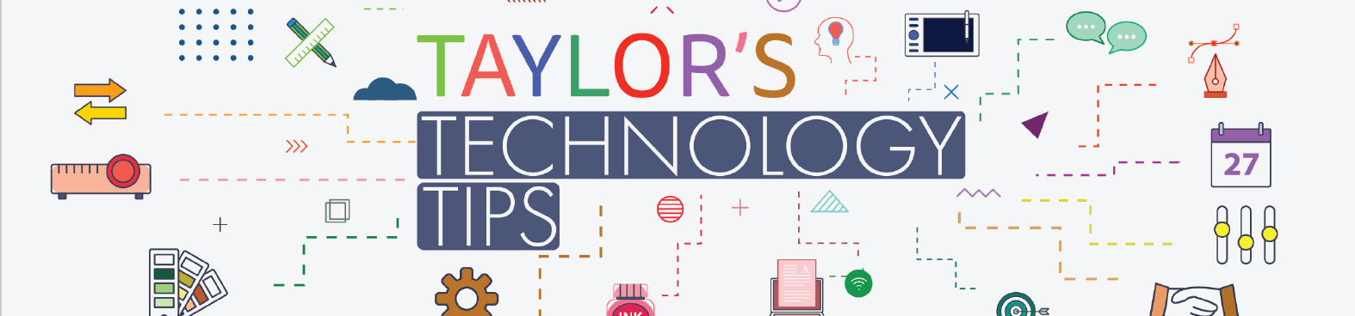
#336: Could You Tell the Difference?
Warning. This article contains distressing information.

Imagine receiving a phone call from your child, partner or parent. They sound distressed, frightened and urgently need help. Your first instinct would be to act immediately.
Unfortunately, criminals are increasingly using AI voice cloning technology to make scams like this more convincing.
A recent case describes how a California mother spent more than five hours believing her daughter had been kidnapped after hearing what sounded exactly like her daughter's voice on the phone. The scammers demanded money, kept her on the line, and prevented her from checking whether the emergency was real. It later emerged that her daughter was safe and had been at work the entire time.
The most important lesson is simple: a familiar voice is no longer proof of identity.
How to protect your family
- Verify any emergency through a second method before taking action.
- Call your loved one back using a number you already know.
- Establish a family safe word or phrase. Remind each other of it regularly.
- Be suspicious of requests for secrecy or urgent money transfers.
- Discuss AI voice scams with children, grandparents and other family members before a scam occurs.
- Never send money based solely on a phone call, even if the voice sounds genuine.
As AI tools become more accessible, digital literacy increasingly includes knowing that voices, images and videos can be manipulated. A short family conversation today could prevent significant financial and emotional harm tomorrow.
Read the original article: AI voice cloning scam fools Navy veteran mom into $5,400 wire transfer
Have a safe half term break with your family and friends.
Brian Taylor
Vice Principal, Technology for Learning

