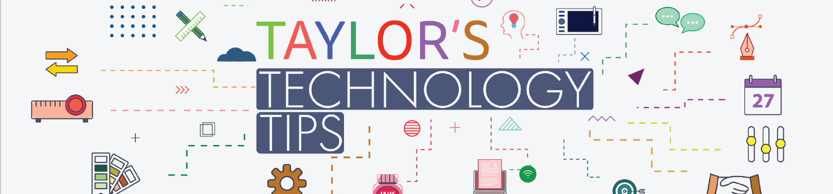
#325: Omoggle & the PSL Scale: A Parent’s Guide to Keeping Your Child Safe
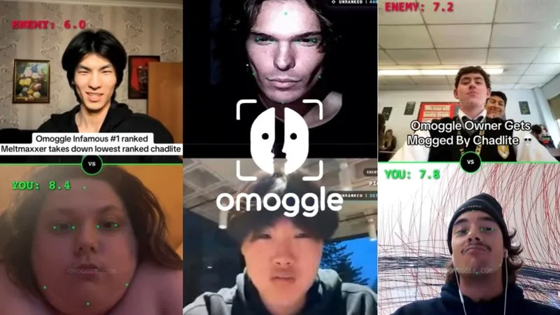
A new online platform called Omoggle is gaining traction among teenagers, particularly through TikTok, X, and now Twitch streaming. It connects users via random live video calls, but with a concerning twist: participants are rated on their appearance using an AI system linked to the “PSL Scale”, a numerical measure of perceived attractiveness. Users compete to “mog” (outscore) others, with results displayed on public leaderboards.
While this may appear similar to past platforms like Omegle, Omoggle introduces additional safeguarding concerns. The unfiltered nature of live video interactions means young people can be exposed to explicit content, inappropriate behaviour, or predatory adults, often before any reporting systems can intervene. There are also significant privacy risks. The platform uses facial scanning technology to analyse and rank users, raising questions about how biometric data is stored, used, or potentially shared. Teenagers may not fully understand the long-term implications of sharing this sensitive data.
From a wellbeing perspective, repeated exposure to appearance-based scoring can negatively impact self-esteem. Experts warn this may contribute to body dysmorphia, as young people begin to fixate on perceived flaws. Public “losses” in these competitions can also be recorded and shared widely, increasing the risk of humiliation and cyberbullying. Parents may notice warning signs such as increased focus on appearance, use of terms like “PSL” or “mogging”, or distress about how their child looks.
What can parents do?
- Keep conversations open and non-judgemental.
- Reinforce that self-worth is not defined by appearance or online scores.
- Set clear expectations for safe and respectful online behaviour.
- Use parental controls and supervise device use where appropriate.
- Encourage children to speak up if they encounter anything uncomfortable.
A simple conversation starter such as “Have you seen Omoggle?” can help keep dialogue open. Strong relationships and ongoing guidance remain the most effective way to support young people navigating online spaces safely.
More information:: https://www.waynedenner.com/omoggle-parent-guide/
Image Source: What Is 'Omoggle'? The 'PSL Scale' Mogging Game Going Viral Online Explained

Have a great weekend.
Brian Taylor
Vice Principal, Technology for Learning

