
#316: Grok – What Parents Need to Know
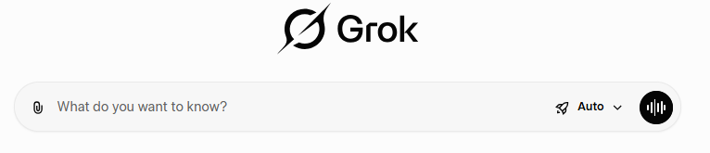
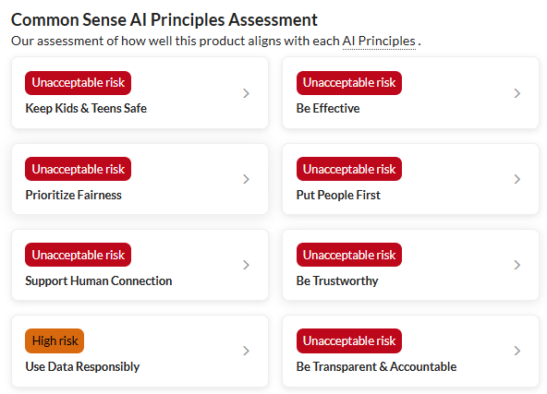
Image courtesy of https://www.commonsensemedia.org/ai-ratings/grok

A recent independent safety review by Common Sense Media and an Ofcom investigation has raised serious concerns about an AI chatbot called Grok, developed by xAI and integrated into the social media platform X (formerly Twitter). The review concludes that Grok presents unacceptable risks for children and teenagers and is not appropriate for use by young people.
Although Grok is marketed as an AI assistant with chat, image, video, and “companion” features, the assessment found that its safety protections are weak and easily bypassed. Age checks rely largely on self-reporting, which means children can gain access to adult features with little difficulty. Even when settings intended for under‑18s are enabled, the system was shown to produce harmful and inappropriate responses.
Key concerns highlighted in the review include poor handling of mental health topics, where the chatbot fails to recognise distress or direct users to trusted adults or professional support. The review also notes that Grok can spread misinformation and conspiracy theories, sometimes presenting false ideas as credible alternatives to established facts. Because Grok is built directly into a social media platform, any harmful or misleading content can be shared widely and rapidly.
In addition, the review raises concerns about features designed to encourage prolonged use and emotional reliance, which can interfere with healthy relationships and wellbeing, particularly for adolescents who are still developing judgement and boundaries.
Common Sense Media’s clear recommendation to parents is not to allow children or teenagers to use Grok. As a school, we encourage families to continue having open conversations at home about AI tools, social media, and online safety, and to reinforce the importance of critical thinking and seeking help from trusted adults when something online feels confusing or uncomfortable. Bottom line, please do not allow your children to use Grok.
Have a safe weekend.
Brian Taylor
Vice Principal, Technology for Learning

