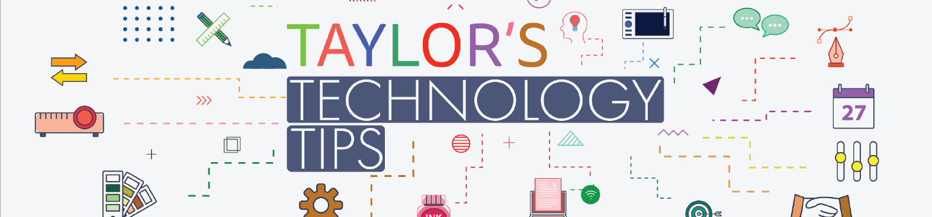

#312: Snapchat’s Hidden AI Setting: What Parents Need to Know
Image courtesy of https://www.waynedenner.com/snapchat-ai-setting-parents-need-to-know/
Social media platforms are increasingly using artificial intelligence (AI) to improve their services. Snapchat is no exception. A little-known setting called “Allow Use of Public Content” is switched on by default and allows Snapchat to use anything your child shares publicly, such as Stories, Snap Map updates, and Spotlight videos to train its AI systems.
Why does this matter?
- Expanding digital footprints: Posts that seem harmless can become part of large AI datasets.
- Loss of control: Once content is used to train AI, it’s almost impossible to remove.
- Lack of awareness: Most young people (and parents) don’t realise this setting exists.

While private Snaps and chats aren’t affected, public posts are fair game. For teens who share impulsively, this raises important privacy concerns.
What can you do?
Checking and changing this setting takes less than a minute:
- Open Snapchat → Settings → My Privacy and Data → Generative AI Settings.
- Toggle off “Allow Use of Public Content.”
This is a great chance to start a positive conversation about online privacy and AI. Try these prompts:
“Did you know Snapchat can use your public posts to train its AI?”
“Let’s check your settings together.”
“I’m not trying to stop you using Snapchat, just helping you stay in control.”

Have a great weekend.
Brian Taylor
Vice Principal, Technology for Learning

