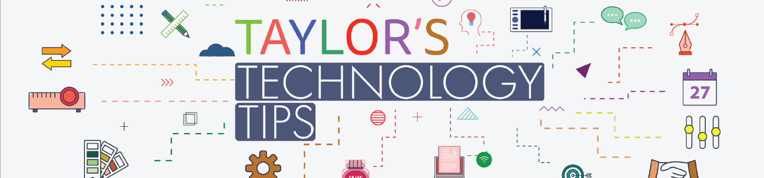

#310: What We All Need to Know About Short Form Videos (YouTube Shorts, TikTok, Reels etc)
Image adapted from: https://www.appletoncreative.com/how-short-form-videos-are-a-long-term-investment-in-your-brands-future/
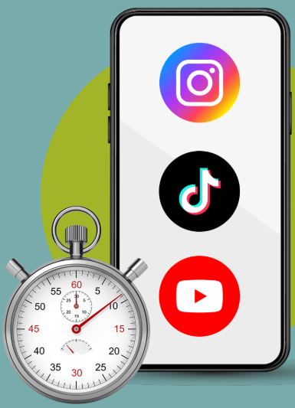
I normally title these tips ‘What Parents Need to Know’. Alas, I feel as though all of us need to know about this one. I find myself easily drawn into watching YouTube Shorts and wonder where the time has gone. Can you imagine how challenging it is for our children to ‘escape’?

Why Short Videos Appeal to Young Minds

Short-form videos (SFVs) like TikTok, Instagram Reels, and YouTube Shorts are designed to capture attention. Younger brains are especially receptive. At this stage of development, children’s brains are wired for exploration and rapid learning. Each quick, surprising clip triggers a strong dopamine response, the chemical linked to pleasure and motivation. These videos also provide instant feedback and constant novelty, which matches how young learners thrive. Multisensory input: bright visuals, catchy sounds, and emotional cues packed into seconds, making the format even more engaging. Add in unpredictable twists and trends, and the brain’s sensitivity to surprise, keeps children (and us) swiping for more.
What the Research Says
SFVs are now a major part of young people’s lives. A recent review of 71 studies involving nearly 100,000 participants found that heavy SFV use is linked to poorer attention and self-control, and weaker memory skills. These patterns may make it harder for children to focus on reading, problem-solving, and sustained learning tasks.

Mental health is also affected. Frequent SFV use is associated with higher stress and anxiety, and lower overall well-being. Sleep quality can suffer when children watch videos late at night, and feelings of loneliness may increase if online interactions replace real-world connections. Interestingly, body image and self-esteem were not consistently affected, but the type of content matters. Positive or educational videos may have different impacts than appearance-focused trends. Read the full paper here APA PsycNet.
Next Steps for Parents

- Set boundaries: Encourage screen-time limits and breaks, especially before bedtime.
- Talk openly: Discuss what your child watches and why. Help them reflect on how it makes them feel.
- Promote balance: Suggest offline activities like sports, reading, playing a musical instrument, non-screen hobbies, long-format co-viewing.
- Model healthy habits: Show mindful use of social media in your own routines.
- Use tools: Explore parental controls and app settings for time reminders.
Let’s all take the control of our time back away from the algorithms!

Brian Taylor
Vice Principal, Technology for Learning

