 |    | 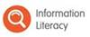  
 |  | 

Dear Colleagues
Here is this week’s instalment of Digital Citizenship news for a rainy day….
Do you know what this useful little icon does?  Next time you are taking the register click on the small icon next to the photo of a student, then click on ‘Show Edit View’……   | 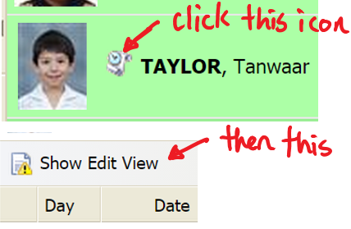
2. Did you catch the BBC article on the OECD Report last week?  The actual report and responses to it are available here. I recommend skipping to the short executive summary on page 17 of the report.   | 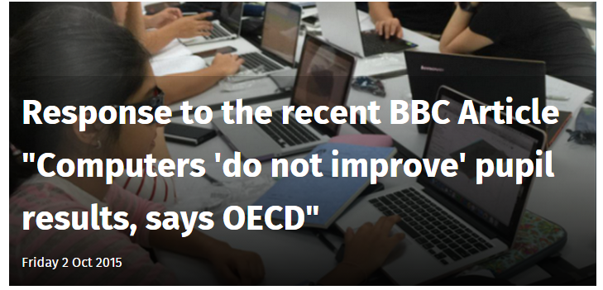
3. Feedback on a PDF?  Not many know about the free annotation tools built into Adobe Acrobat reader – they are very powerful and simple to use! | 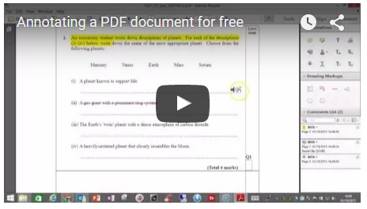  https://www.youtube.com/watch?v=vXiPJmizyPE
4. ICT FAQ: When can I install Windows 10 on my school laptop?   | A. The IS/IT team are testing for compatibility of Windows 10 and our current systems. They’ve found issues that need more time to resolve and updates from manufacturers are in the pipeline. They are setting a Term 2 target date for Windows 10 support. Please continue to use Windows 8 or Windows 8.1 on all school owned devices and dismiss notifications to update to Windows 10 if they appear.
5. What are our ICT Advocates up to?  The Staff and Student ICT advocates meet once a month to feedback on technology they have been trialling. | Do you know who’s the Staff ICT Advocate for your team? This month our advocates are looking at a Formative Assessment Tool called Plickers, revisiting a Primary favourite called Espresso and experimenting with a new Snip tool from Microsoft. Have a chat with your advocate for further information.
6. Meet the IS/IT Team:   |   This week’s member of the IS/IT team is Varakorn Lerksirisuk. Khun Arm (vale@patana.ac.th) is first line support on the IS/IT helpdesk. He’s the newest member of the team so please take a moment to say hello when you see him.

Copies of these Digital Citizenship emails will be posted on the Digital Citizenship blog.
As always, contact Callum or myself for ICT training or support.
Safe Surfing
Brian

