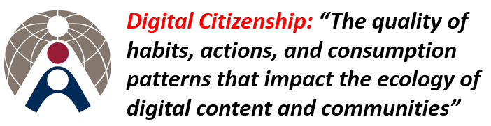 |    |   
 |  | 

Dear Colleagues
Here is this week’s instalment of Digital Citizenship news:
1. Super quick way to force users to make a copy of your Google Doc rather than edit the original.   | http://www.alicekeeler.com/teachertech/2014/12/10/google-docs-force-students-to-make-a-copy/  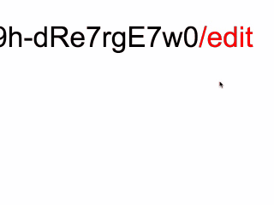  When you create a Google Doc the default security setting is ‘visible by anyone at Patana with the link’. If the information is sensitive make sure you change this setting. Do not share content with users outside of the Patana domain. The ability to share ‘publicly’ will be deprecated on Aug 31 2016. More info here.
2. Java updates – when installing the latest version make sure you un-check the Yahoo search engine tick box.   | 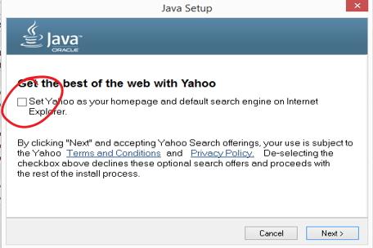
3. External ICT CPD Events: it’s that time of year when PM objectives may have an ICT related component. Take a look at events on offer outside of Patana and discuss with your Line Manager.   | 
4. The Patana Journal is looking for writers – if you’re interested contact Sal (safl@patana.ac.th). Past issues available on the right | 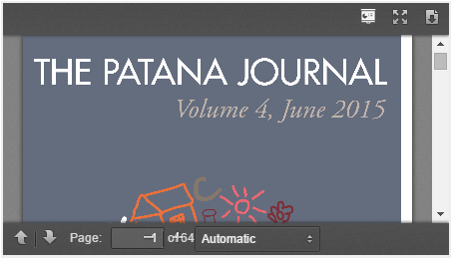
5. Meet the IS/IT Team:   | This week’s member of the IS/IT team is Khun Wimonsiri Komthongchusakul. Khun Wi (wiko@patana.ac.th) is responsible for teacher devices in Year 1 to 6, the student laptops in Year 5 and over at the tennis office. If you see her on your travels say hello and ask her why she wears a headscarf in the IS/IT office…..

Copies of these Digital Citizenship emails will be posted on the Digital Citizenship blog.
As always, contact Callum or myself for ICT training or support.
Have a dry weekend
Brian

