Learning about Periods
When do periods start?
Most girls start their periods between the ages of 9 and 16.
The average age is around 12 or 13 – but some will start earlier, and some will start later.

How long does a period last?
Periods usually last about four or five days.
Sometimes they only last two or three days.
Once you start menstruating, you will have a period once a month.

What products do girls use when they have a period?
You'll need to use something to absorb the very slow flow of menstrual blood.
It is best to experiment and give different products a try.

Period pants
Some girls like period pants because they are so easy to use and far more environmentally sustainable as they can be safely washed and re-used.

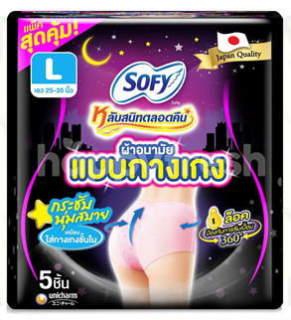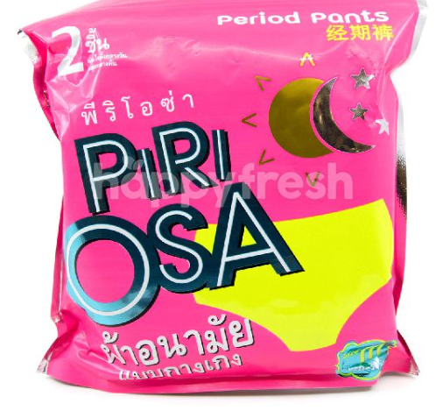

Stick-on pads
Pads are made of layers of cotton with a sticky strip that sticks to your underwear. Pads come in several different thicknesses. There are even pads for night-time so that you can sleep without worrying about having to change your pad.
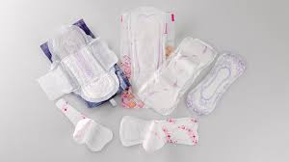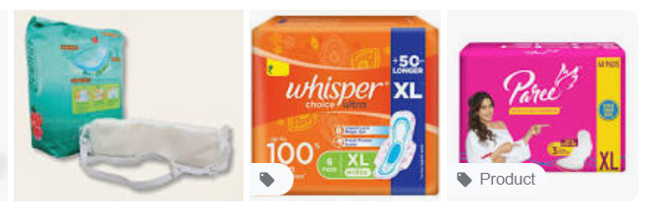

Tampons
Tampons absorb blood flow from inside the vagina and are made in many different sizes. Tampons have a string attached to one end that stays outside your body and is then used to gently pull the tampon out. It gets easy with practise.
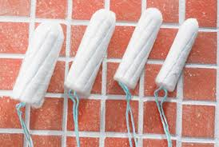
Once you are ready to remove a tampon, pull gently on the string that is attached to the end of the tampon and slide the tampon out.
What to do with a pad or tampon after use
Once you've removed the pad or tampon, wrap it in toilet paper and put it in the bin.
If you are in school, you can put it in a special sanitary bin.
Never put sanitary products down the toilet.

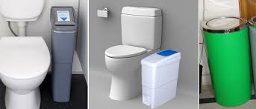

Relationship and Sex Education (RSE)
May 2022

