

#205: Technology For Learning Weekly Review

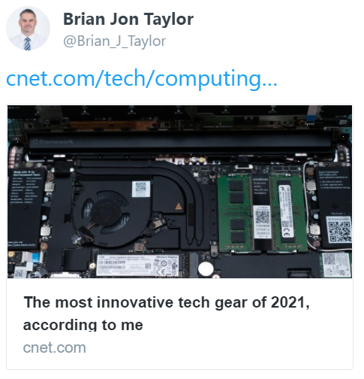
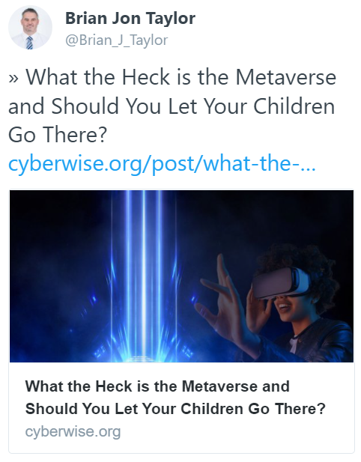

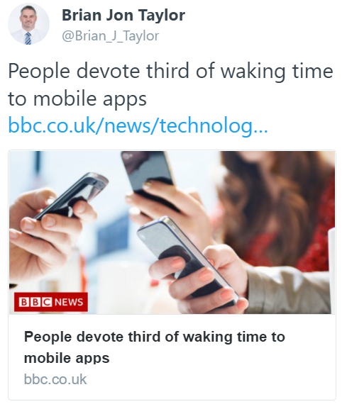
Happy New Year everyone. Please find linked below four tech-related posts I found interesting this week.
Have a relaxing weekend.
Brian Taylor
Assistant Principal, Campus Curriculum Technology Integration

