

#201: Technology For Learning Weekly Review

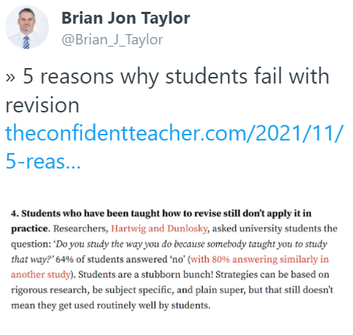

I would like to share with you highlights of my recent digital travels...

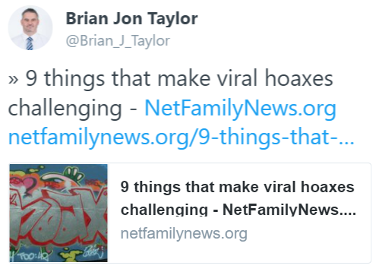
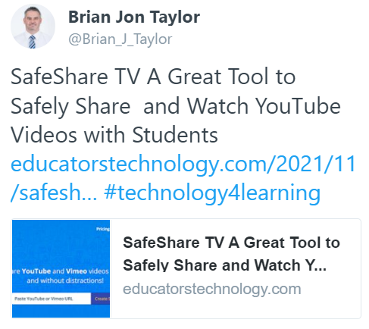
Have a great weekend.
Brian Taylor
Assistant Principal, Campus Curriculum Technology Integration

