

#196: Technology For Learning Weekly Review

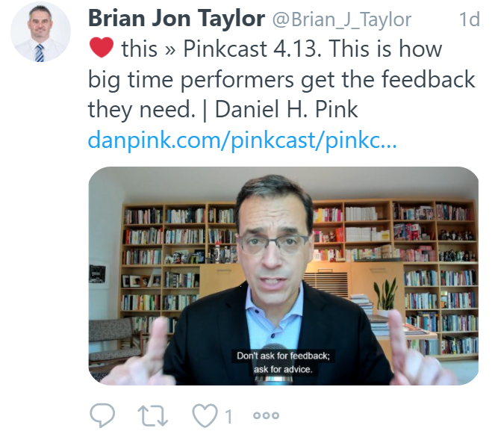

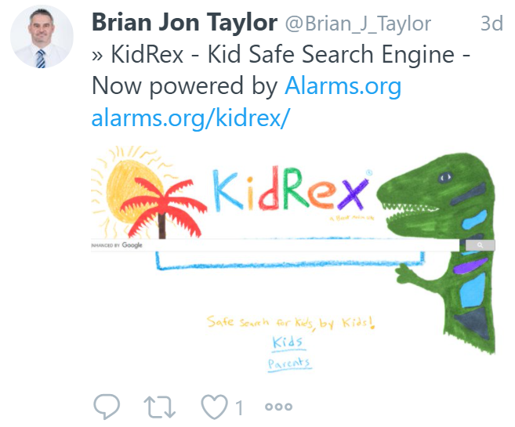
Find below some of the highlights of my digital travels this week.

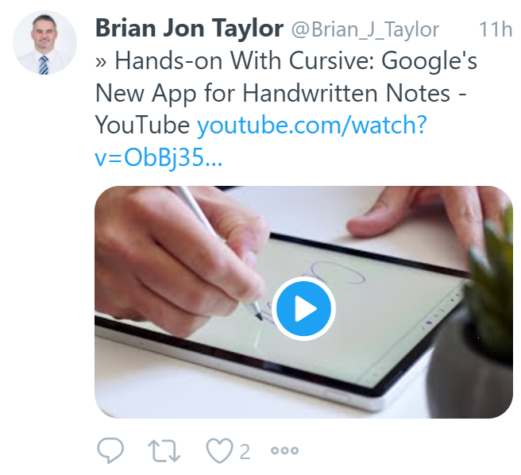
Have a great weekend.
Brian Taylor
Assistant Principal, Campus Curriculum Technology Integration

