
#193: Cybersecurity

You may have caught the news this week regarding the spate of cyberattacks on organisations in and around Thailand: Warning over cyberattack threats (bangkokpost.com).

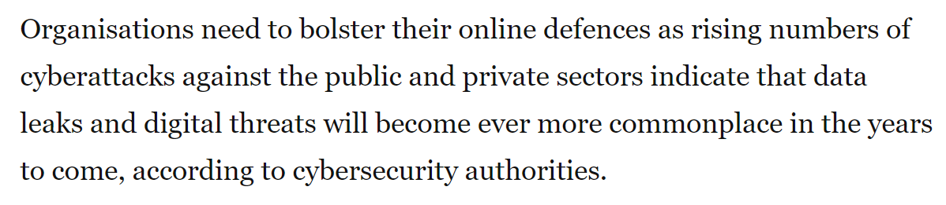

At our school we continuously scan all our accounts for ‘signatures’ that they have been compromised. Typical ‘signatures’ include malware linked IP addresses, unfamiliar sign-in properties and atypical travel. We classify the account into low, medium and high risk. For risky accounts we contact the individual and assist them in changing their password and signing out of all devices. Helpdesk@patana.ac.th can guide you through the process of changing your password, or you can do it yourself (students & staff) by following the instructions in the video below:

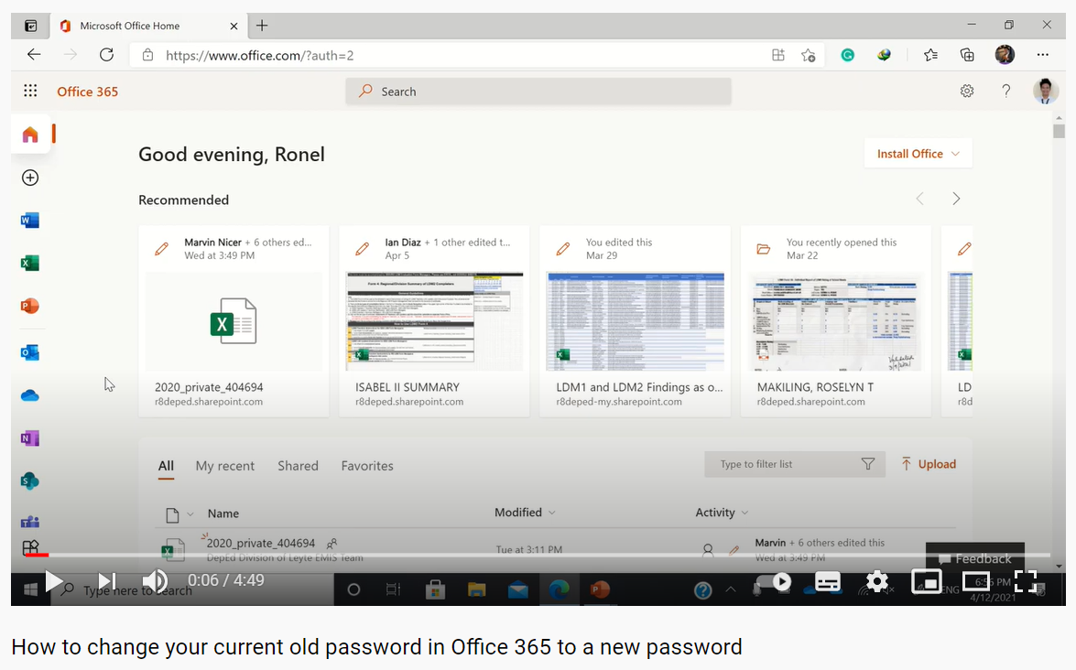

Younger students can use this password generator: DinoPass - Simple password generator for kids. We recommend everyone follow the steps on this site with regards to keeping your online accounts safe: Top tips for staying secure online - NCSC.GOV.UK

Have a safe weekend.

Brian Taylor
Assistant Principal, Campus Curriculum Technology Integration

