
#187: Breaking the Laws of Physics?

I’m sure many of you, like me, hit the subscribe button on YouTube but never really do much more with those subscriptions. Rather, you get sucked into the suggested videos on the right-hand side bar when you’re watching something you searched for. What I like to suggest is that you make the Subscriptions - YouTube page your default browser tab for YouTube, rather than simply the YouTube homepage. That way, you have a small modicum of control over what appears when you navigate to YouTube, not the YouTube algorithm suggestions based on your viewing history.



There are very few YouTube channels that I “click the bell” icon on. One of them is Veritasium. For over ten years, with over nine million subscribers, Derek Muller is an Australian-born Canadian science communicator that has a real knack of unravelling science related phenomenon. His latest below is an instant classic. Can a wind-powered vehicle move faster than the wind in the same direction of the wind? If you don’t believe me, rather than watch an episode of your favourite series on NetFlix, take an alternative 20 minutes to watch Derek’s latest video. You may be inspired to click subscribe and hit that bell…

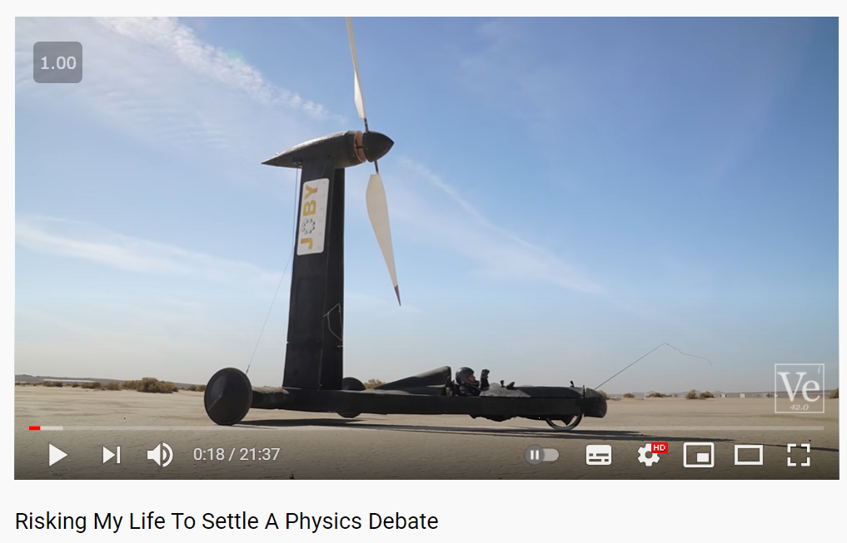

Have a great weekend.

Brian Taylor
Assistant Principal, Campus Curriculum Technology Integration

