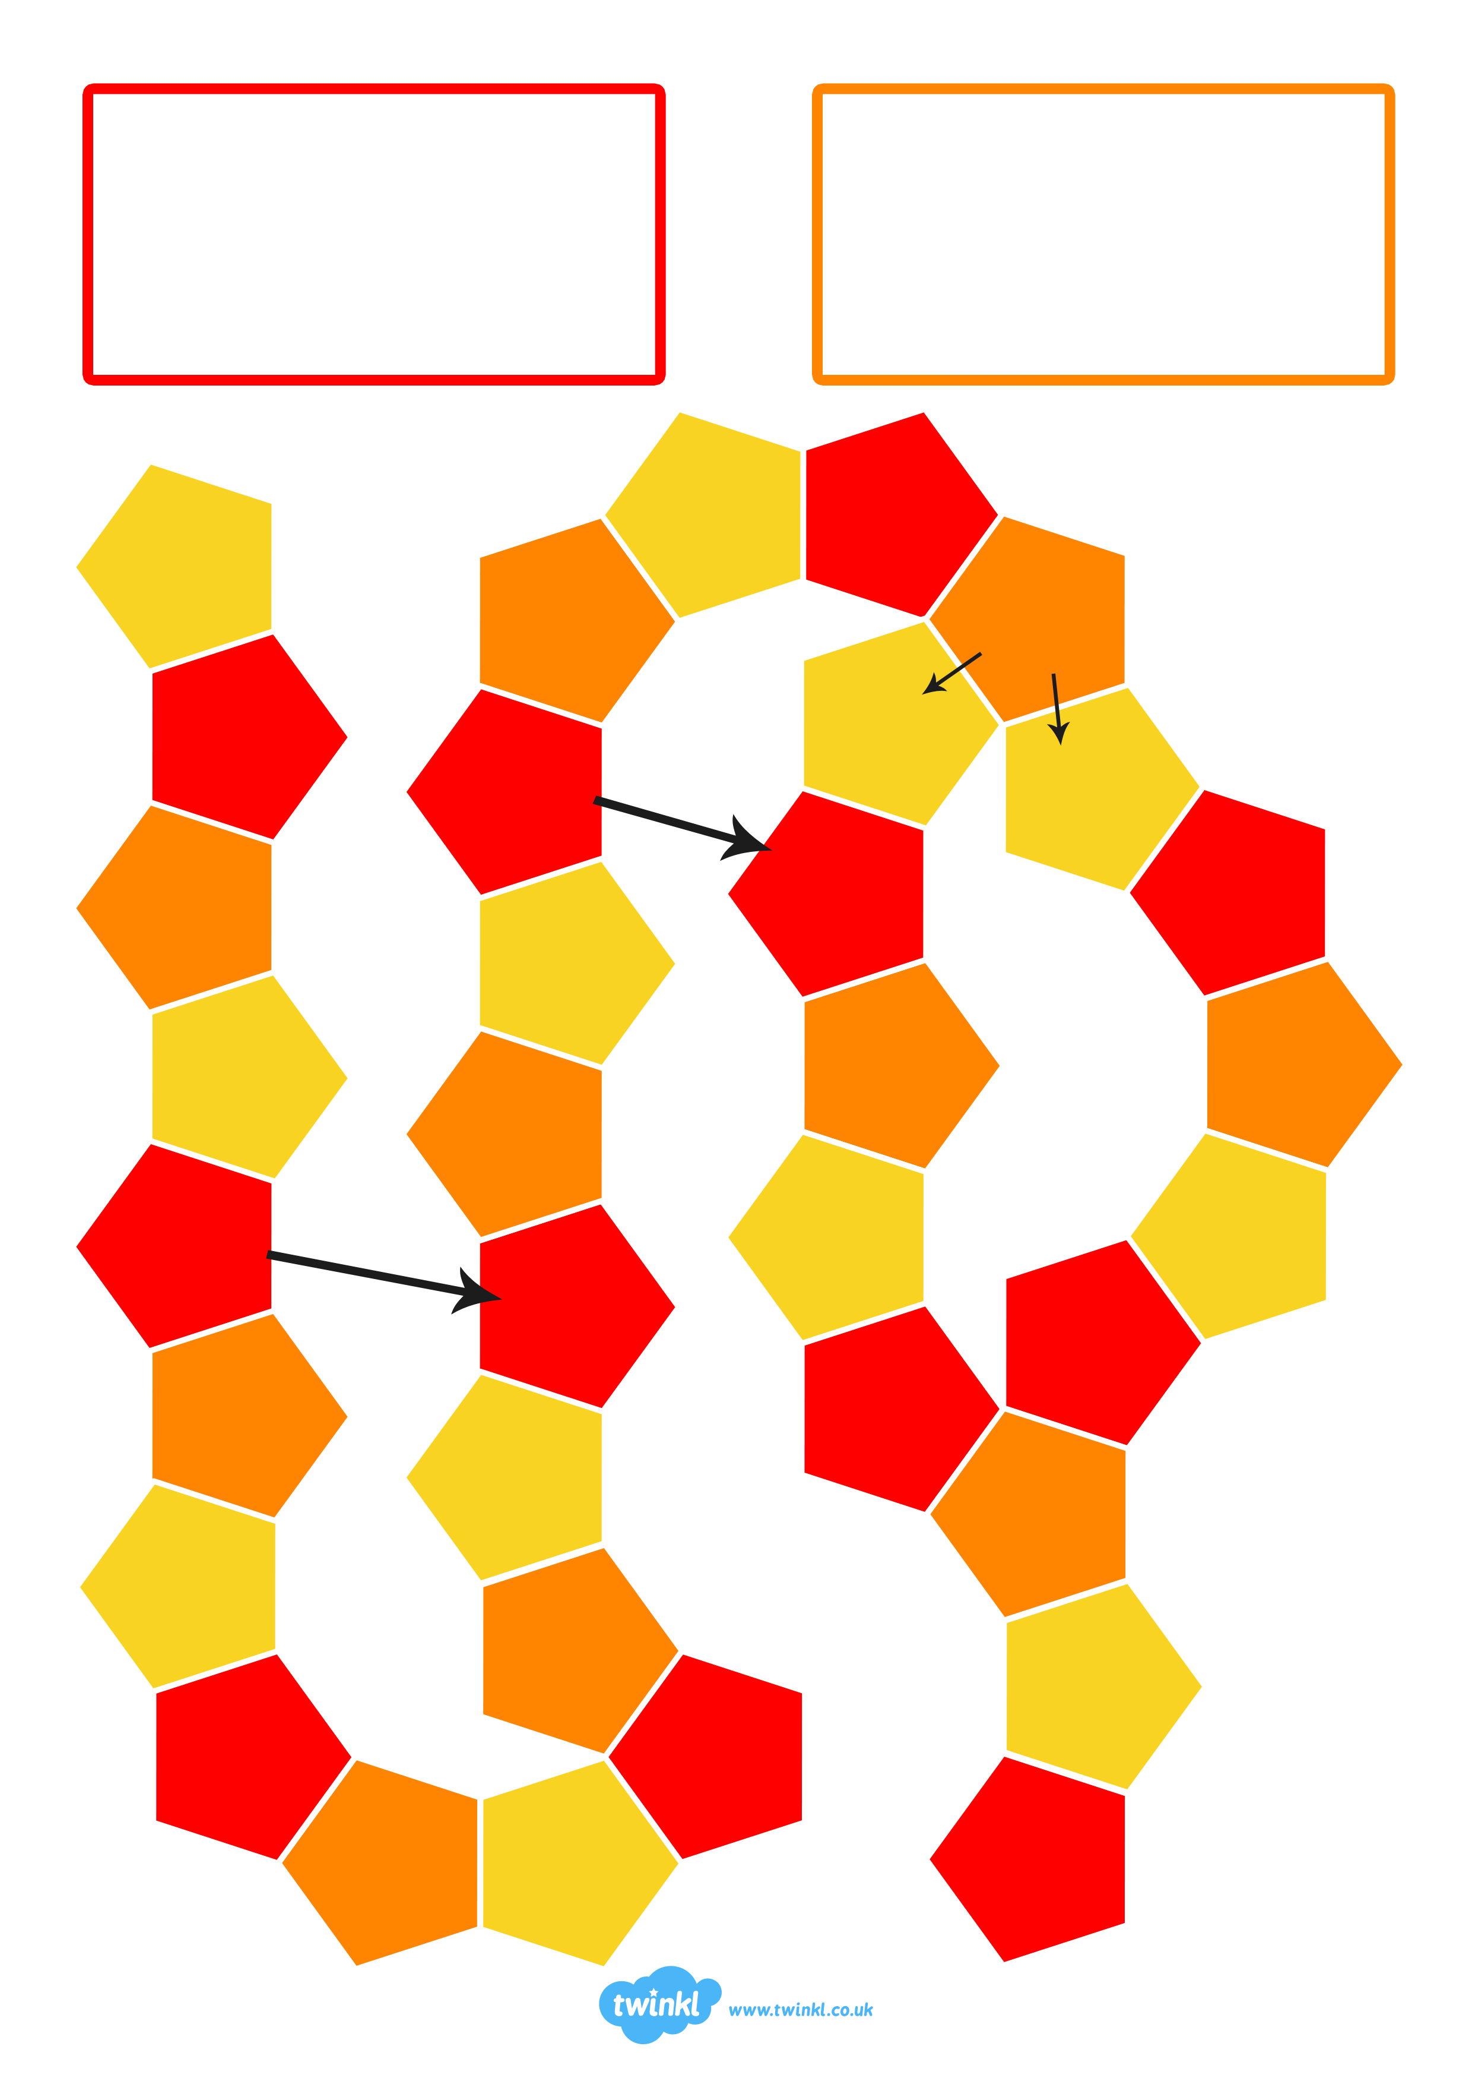
Start
Short Cut
Short Cut
Finish

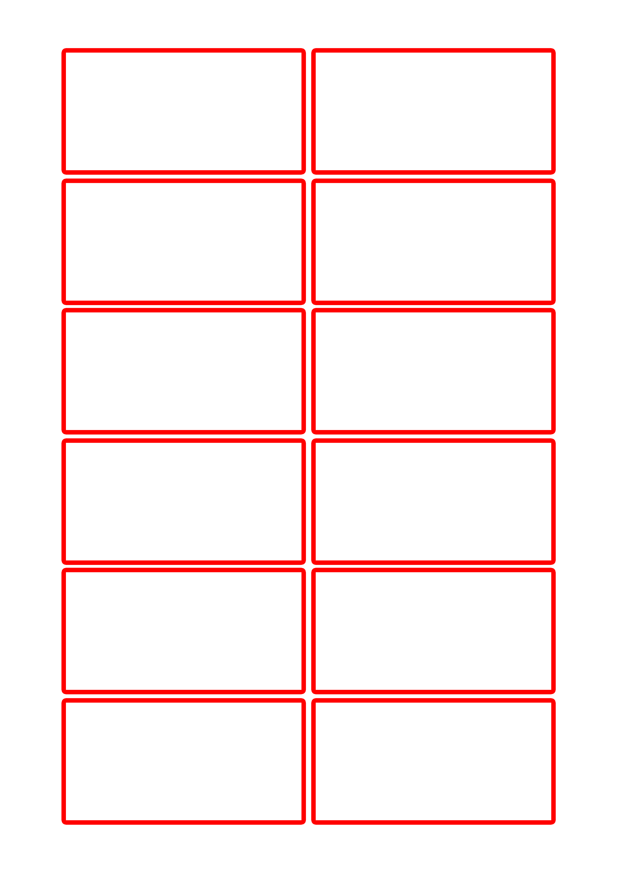

Text Here

Text Here

Text Here

Text Here

Text Here

Text Here

Text Here

Text Here

Text Here

Text Here

Text Here

Text Here

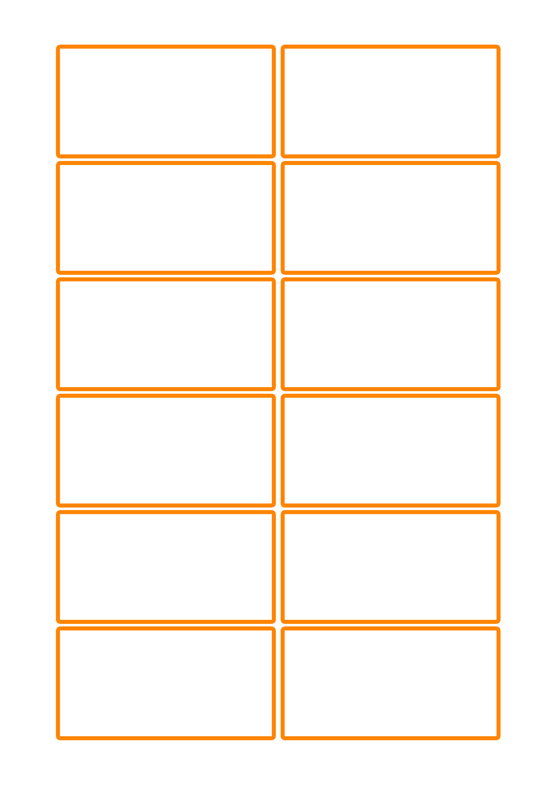

Text Here

Text Here

Text Here

Text Here

Text Here

Text Here

Text Here

Text Here

Text Here

Text Here

Text Here

Text Here

