Ready to start packing?
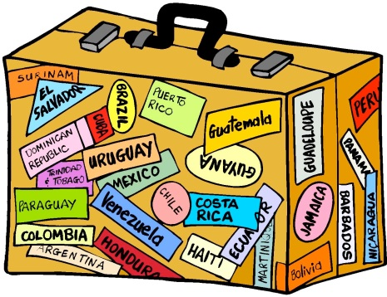
Here’s a helpful list….
- 2 pairs of shorts
- 4 T-shirts
- 4 pairs of socks
- 4 pairs of underwear
- 1 pair of long trousers or jogging pants
- Sandals/flip flops
- Trainers or comfortable shoes suitable for activities
- Change of smart clothes for dinner
- Sweatshirt
- Pyjamas/nightdress
- Swimsuit and towel
- Plastic bag for dirty laundry
- Toiletries packed in a toilet bag (including mosquito repellent)
- Sunglasses and sun cream
- Reading or puzzle books
- Favourite comforter for bedtime – teddy bear, blanket etc.
- Small backpack for the picnic
- Rash Vest for pool/beach
- Named Water Bottle
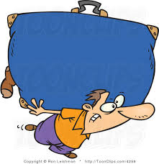
Remember... your bag must not be too big. Make sure you’re able to carry it!!

